Supporting document 1

Systematic Review of the Evidence for a Relationship between Oats, Barley and their derived β-glucans on Blood Cholesterol Concentration

Prepared by: Food Standards Australia New Zealand

Date: August 2015

Executive Summary
This report covers three separate but related relationships for foods or properties of foods which might affect blood cholesterol: β-glucan from oats or barley (as pre-approved in Standard 1.2.7 – Nutrition, Health and Related Claims), oats, and barley.

Does intake of β-glucan from oats or barley affect blood cholesterol concentration?
Food-health relationship | Dietary intake of β-glucan from oats or barley reduces blood cholesterol concentration
Degree of certainty (GRADE rating) | Non-assessable
Component | Notes
Body of evidence | 57 strata (trial arms) from 54 randomised controlled trials (RCTs), comprised of 46 oat strata and 11 barley strata, were included in the systematic review. No RCT measured the effect of pure β-glucan. All studies, including those which investigated extracted/concentrated oats or barley, included other fibres and food components in addition to β-glucan. Therefore, the relationship could not be assessed.
Consistency | Consistency could not be assessed because there were no trials which would allow the effect of β-glucan to be separated from the effects of other components in the food products.
Causality | RCTs are a strong study design for causality. However, because no available RCT used 100% pure β-glucan, no conclusion can be drawn regarding the consumption of β-glucan from oats or barley and reduced blood cholesterol concentration.
Plausibility | It is plausible for β-glucan to lower blood cholesterol by increasing viscosity in the gastrointestinal tract, thereby reducing or affecting cholesterol uptake and bile-acid re-uptake, as well as through other effects on cholesterol homeostasis. It is plausible that other fibres or other components in oats or barley also have this effect.
Generalisability | The systematic review included RCTs from Australia and New Zealand, the US, Canada, Europe and Asia published between 1988 and 2013.

The relationship between β-glucan from oats or barley and blood cholesterol is in Schedule 2 of Standard 1.2.7 – Nutrition, Health and Related Claims (Australia New Zealand Food Standards Code, 18 January 2013). Schedule 2 lists food-health relationships that can be used to underpin high level health claims. The purpose of this systematic review was to determine the currency of this food-health relationship. In doing this review, FSANZ has followed the requirements of the Food Standards Australia New Zealand Application Handbook and of Schedule 6 of Standard 1.2.7 for the required elements of a systematic review.

No RCT identified in the literature search has assessed the effects of intake of 100% pure β-glucan on blood cholesterol concentration. Fifty-four RCTs, containing 57 strata (trial arms), were included in the review. However, as none of the studies tested pure β-glucan, they did not directly test the effects of β-glucan on blood cholesterol. Therefore, FSANZ considers that the results described in the literature cannot be unequivocally attributed to β-glucan, but can only be attributed to the tested product. In conclusion, the currency of a food-health relationship between β-glucan from either oats or barley and blood cholesterol concentration cannot be assessed.

A condition in Standard 1.2.7 for making a claim about β-glucan from oats or barley and blood cholesterol specifies that the food must contain wholegrain oats, oat bran or wholegrain barley. FSANZ extended the analysis to separately assess food-health relationships between: 1) oats and blood cholesterol concentration; and 2) barley and blood cholesterol concentration.
Does intake of oats affect blood cholesterol concentration?
Food-health relationship | Dietary intake of wholegrain oats or oat bran reduces blood total and LDL cholesterol concentrations
Degree of certainty (GRADE rating) | Total and LDL cholesterol: ⊕⊕⊕⊕ High
Component | Notes
Body of evidence | 32 randomised controlled trials (RCTs) with 33 strata for oats were included in this systematic review and the oats meta-analysis.
Consistency | The majority of RCTs showed decreased total and LDL cholesterol concentrations after consumption of oats.
Causality | RCTs with low risk of bias testing a substantial number of participants is a strong study design for causality. Therefore the meta-analysis results support a causal link between consumption of oats and reduced blood total and LDL cholesterol concentrations.
Plausibility | It is plausible that soluble fibre (and/or other factors) in oats reduces blood cholesterol by increasing viscosity in the gastrointestinal tract, thereby reducing or affecting cholesterol uptake and bile-acid re-uptake, as well as through other effects on cholesterol homeostasis.
Generalisability | The systematic review included RCTs conducted on 2006 participants from Australia, New Zealand, USA, Canada, Europe, Asia and the Middle East published between 1988 and 2014. The effect was demonstrated in both sexes in Australian and New Zealand populations. The effect was evident in normo- and hyper-cholesterolaemic participants.

Oats in this review is limited to oat bran and wholegrain oats that have been processed by basic physical operations such as cleaning, grading, dehulling, drying, cutting, flaking, rolling and grinding (Decker et al. 2014). Thirty-two RCTs for wholegrain oats or oat bran were included in the review, with 33 strata included in the meta-analysis. Other strata were excluded because they used barley, or poorly defined concentrated and heavily processed oat or barley fibre. The meta-analysis showed that consumption of oats significantly changed total and low density lipoprotein (LDL) cholesterol concentrations by -0.22 and -0.21 mmol/L, respectively. However, there was no change (0 mmol/L) in HDL cholesterol concentration.

The relationship between oats and blood total and LDL cholesterol concentrations was shown to be both consistent and causal, with plausible mechanisms to explain the observed effect. Sub-group analysis showed that the effect was similar in men and women. The magnitude of the effect was slightly greater in trials of participants with normal blood cholesterol status (< 5.5 mmol/L blood total cholesterol) compared with trials of participants with high blood total cholesterol (≥ 5.5 mmol/L), though this difference was not statistically significant. The effect was present in high quality studies. There was no effect of source funding on the effects described.

The body of evidence demonstrates that the relationship between oats and reduction of blood total and LDL cholesterol concentrations is substantiated with a ‘High’ degree of certainty.
Does intake of barley affect blood cholesterol concentration?
Food-health relationship | Dietary intake of wholegrain barley reduces blood total and LDL cholesterol concentrations
Degree of certainty (GRADE rating) | Total and LDL cholesterol: ⊕⊕⊕ Moderate
Component | Notes
Body of evidence | 7 randomised controlled trials (RCTs) with 7 strata for barley were included in this systematic review and the barley meta-analysis.
Consistency | All studies showed a decrease in total cholesterol and the majority showed a decrease in LDL cholesterol concentration after consumption of barley, although not all results were statistically significant.
Causality | A RCT is a strong study design for causality. However, fewer than 200 participants were tested across 7 trials. Therefore, although the meta-analysis results support a link between consumption of barley and reduced blood total and LDL cholesterol concentrations, the relationship did not achieve a high degree of certainty.
Plausibility | It is plausible that soluble fibre (and/or other factors) in barley lowers blood cholesterol by increasing viscosity in the gastrointestinal tract thereby inhibiting cholesterol uptake and bile-acid re-uptake, as well as through other effects on cholesterol homeostasis.
Generalisability | The systematic review included RCTs conducted on 185 participants from Australia, the US, Europe and Asia published between 1989 and 2014. The effect was seen in normo- and hyper-cholesterolaemic participants; however only 24 people with normal cholesterol concentrations were tested.

Barley in this review is limited to wholegrain barley and barley products that have been processed using basic physical operations such as cleaning, grading, dehulling, drying, cutting, flaking, pearling, rolling and grinding (Newman and Newman 2008). Seven RCTs were included in the review, with 7 strata included in the meta-analysis. Other strata from the review were excluded because they used oats or poorly defined concentrated and heavily processed barley or oats fibre. The meta-analysis demonstrated that consumption of barley significantly changed total and LDL cholesterol concentrations by -0.32 and -0.25 mmol/L, respectively. In contrast, there was no significant effect on HDL cholesterol concentration (-0.03 mmol/L).

The relationship between barley and blood total and LDL cholesterol concentrations was shown to be consistent, with plausible mechanisms to explain the observed effect. The magnitude of the noted reduction was significant regardless of the participant’s blood cholesterol status, that is, whether they had a normal concentration (< 5.5 mmol/L blood total cholesterol concentration) or were hypercholesterolaemic (≥ 5.5 mmol/L). However, the GRADE was down-rated for serious imprecision due to the low number of participants. Therefore, FSANZ considers that the body of evidence demonstrates that the relationship between barley and reduction of blood total and LDL cholesterol concentration has a “Moderate” degree of certainty.
Contents
Executive Summary i
1 Introduction 1
1.1 Food or property of food 1
1.2 Health effect 2
1.3 Proposed relationships 2
2 Evaluation of evidence 3
2.1 Methods 3
2.1.1 Search strategy 3
2.1.2 Inclusion and exclusion criteria 3
2.1.3 Study selection, data extraction and quality assessment 4
2.1.4 Statistical analyses 4
2.1.5 Subgroup analyses 5
2.2 Results 6
2.2.1 Search results 6
2.2.2 Included studies 8
2.2.3 Extracted data 9
2.2.4 Quality assessment of individual studies 9
2.3 Evidence for β-glucan and blood cholesterol concentration 10
2.4 Evidence for the effect of dietary intake of oats on blood cholesterol concentration 11
2.4.1 Total cholesterol 13
2.4.2 LDL cholesterol 14
2.4.3 HDL cholesterol 15
2.4.4 Sub-group analyses 15
2.5 Evidence for the effect of dietary intake of barley on blood cholesterol concentration 21
2.5.1 Total cholesterol 22
2.5.2 LDL cholesterol 22
2.5.3 HDL cholesterol 22
2.5.4 Sub-group analyses and publication bias 23
3 Weight of evidence 25
3.1 Assessment of body of evidence 25
3.1.1 Consistency of relationship 25
3.1.2 Causality 25
3.1.3 Plausibility 26
3.2 Applicability to Australia and New Zealand 27
3.2.1 Intake required for effect 27
3.2.2 Target population 27
3.2.3 Adverse effects 27
4 Conclusion 27
5 Acknowledgment 27
6 References 28
Appendix 1 – Electronic search strategy 35
Appendix 2 – Studies excluded at full text review 36
Appendix 3 – Characteristics of included studies 37
Appendix 4 – Summary of risk of bias for studies included in the two meta-analyses 61
Appendix 5 – Risk of bias of studies included in the systematic review 62
Appendix 6 – GRADE summary of findings table for β-glucan 67
Appendix 7 – GRADE summary of findings table for oats* 68
Appendix 8 – GRADE summary of findings table for barley* 69

Introduction
The currency of pre-approved food-health relationships underpinning high level health claims is being considered during the transition period for Standard 1.2.7 – Nutrition, Health and Related Claims. The relationship between β-glucan from oats or barley with blood cholesterol levels was included as a pre-approved high level health claim in Schedule 2 of Standard 1.2.7 (see Table 1) based on health claims approved overseas (January 2013). The purpose of this report is to assess the currency of this relationship.
Table 1: Pre-approved high level health claim for β-glucan from oats or barley included in Schedule 2 of Standard 1.2.7
Food or property of food | Specific health  effect | Relevant population | Context claim statements | Conditions
Beta-glucan | Reduces blood cholesterol |  | Diet low in saturated fatty acids  Diet containing 3 g of beta-glucan per day | The food must contain –  (a) one or more of the following oat or barley foods –  (i) oat bran;  (ii) wholegrain oats; or  (iii) wholegrain barley; and  (b) at least 1 g per serving of beta-glucan from the foods listed in (a).

Between 2009 and 2011, the European Food Safety Authority (EFSA) published four scientific opinions relating to the effects of β-glucan from oats or barley on blood cholesterol concentration (EFSA 2009; EFSA 2010; EFSA 2011a; EFSA 2011b). However, the reporting of these evidence assessments provided insufficient detail for FSANZ to formally update them and meet the substantiation requirements of Standard 1.2.7. Similarly, the summary of the evidence assessment of similar claims published by Health Canada does not provide sufficient evidence for a formal update (Health Canada 2010; Health Canada 2012). Therefore, while the evidence in these reports was considered in this review, further work was necessary to meet the requirements of Standard 1.2.7.

Three existing systematic reviews were identified as potential starting points for this evidence assessment (Talati et al. 2009; Abumweis et al. 2010; Tiwari and Cummins 2011). However, further consideration of these reports found they were not suitable for updating due to ambiguity regarding the search strategy, quality assessment of included studies or overly restrictive inclusion and exclusion criteria. Therefore, a new systematic review of the literature relating to the effects of β-glucan from oats and barley on blood cholesterol concentration was prepared.

Food or property of food
β-glucans are non-starch polysaccharides made of glucose molecules linked by β-glycosidic bonds and located in the endosperm cell walls (Wood 2002; Vasanthan and Temelli 2008). The content and molecular weight of β-glucan varies between and within cereals, with higher molecular weight forms having greater viscosity and lower water-solubility (Kim and White 2013). High levels of β-glucan are found in the bran of oats (Avena sativa) and barley (Hordeum vulgare) with an average content around 5% w/w, with much lower levels in other grains such as wheat and rye (Wood 2002; Shewry et al. 2013). Available technologies for extracting β-glucan from oats and barley can increase β-glucan by up to 30% by dry separation processes and up to 65% by wet separation processes (Vasanthan and Temelli 2008; Limberger-Bayer et al. 2014). Specialised plant breeding programs can also produce cultivars with naturally higher levels of β-glucan, e.g. BarleyMaxTM, produced by the CSIRO, contains 10% w/w β-glucan (Topping et al. 2003). Other sources of β-glucan include baker’s yeast and fungi, although it is important to note that β-glucan from these sources is not chemically identical to that from oats and barley, and levels are much lower (fungi: 0.2–0.5% β-glucan) (Manzi and Pizzoferrato 2000). For the purpose of the food-health relationships, only β-glucan derived from oats and barley was considered.

Unlike products obtained by enzymatic and solvent extraction of barley or oat fibres (e.g. β-glucan enriched extracts: Vasanthan and Temelli 2008; Limberger-Bayer et al. 2014), oat or barley bran and other products like steel-cut oats or barley, rolled oats or barley, oat or barley flakes, pearled barley, groats, flour, meal, bran and hulls are not remarkably different in their nutritional composition from wholegrain oats or barley (Guillon and Champ 2000; Decker et al. 2014). In this review, the term ‘oats’ is used to mean wholegrain oats and oat bran, unless otherwise specified.

For the analyses of the relationships involving oats and barley, the terms ‘oats’ and ‘barley’ refer to the forms stated in Standard 1.2.7 (i.e. wholegrain oats, oat bran and wholegrain barley). Chemically concentrated or extracted forms of oats and barley were excluded from the meta-analyses.

Health effect
In Schedule 2 of Standard 1.2.7 the health effect relating to β-glucan from oats or barley is ‘reduces blood cholesterol’. Reductions in total and LDL cholesterol are considered to be beneficial health effects due to elevated concentrations of these blood lipids being risk factors for coronary heart disease (CHD). In contrast, high density lipoprotein (HDL) cholesterol concentrations are inversely related to CHD, but their predictive power for CHD incidence is less certain.

Hypercholesterolaemia is described in Australia as being total serum cholesterol concentrations ≥5.5 mmol/L (AIHW 2012). Total cholesterol can be measured in serum or plasma by various gravimetric, enzymatic or colourimetric methods as well as spectrophotometry. For LDL and HDL cholesterol, several methods can be used including chemical precipitation, spectrophotometric quantification or the Friedewald calculation (Miller et al. 2010).

Proposed relationships
The proposed food-health relationships are:

- dietary intake of β-glucan from oats or barley reduces blood cholesterol concentration
- dietary intake of wholegrain oats or oat bran reduces blood total and LDL cholesterol concentrations
- dietary intake of wholegrain barley reduces blood total and LDL cholesterol concentrations.

Specifically, it is the reduction of total and/or LDL cholesterol concentration that represents a beneficial health effect, whereas reduction in HDL cholesterol concentration is considered an adverse health effect.

Evaluation of evidence
A systematic review of the literature was performed to test the hypothesis that consumption of oats or barley, as sources of β-glucan, decreases blood total and LDL cholesterol. The effect of oats and barley on decreasing HDL cholesterol was also assessed, as decreases in HDL cholesterol concentrations are considered an adverse effect.

Methods

Search strategy
A search was conducted in EMBASE, PubMed and Cochrane CENTRAL in November 2013. The PubMed search was restricted to the six months prior to the EMBASE search date in order to capture articles in the Medline database that may not yet have been incorporated into the EMBASE database. There were no date restrictions for the EMBASE or Cochrane CENTRAL search. A second search was conducted on 12th December 2014, using the same search strategy used in November 2013 and covering the intervening time period. Detailed search strategies are presented in Appendix 1.

Hand-searching was performed on the reference lists of articles screened on full-text. In addition, studies included in other systematic reviews of the effects of β-glucans were screened (Wood 2002; Talati et al. 2009; Abumweis et al. 2010; Tiwari and Cummins 2011; Whitehead et al. 2014), as were the EFSA scientific opinions on related health (EFSA 2009; EFSA 2010; EFSA 2011a; EFSA 2011b). Six papers were identified using this method.

Inclusion and exclusion criteria
The eligibility criteria are summarised in Table 2. To be included in the systematic review, the trial must have been randomised and included an appropriate control group. Study populations could include adults or children (>2 years of age), and individuals with chronic non-communicable diseases such as diabetes, hyperlipidaemia or hypertension.

The β-glucan intervention could be provided as whole oats or barley or their products (for example, wholegrain flour), bran from oats or barley, concentrated forms of oats or barley or purified β-glucan extracted from oats or barley. The comparator was either an alternative grain/cereal intervention, with minimal or no β-glucan (such as wheat or rice), or a usual diet without addition of oats or barley. Although Standard 1.2.7 only allows a β-glucan claim to be made in relation to wholegrain oats, oat bran or wholegrain barley, these other forms were included in the search because a study of pure β-glucan would provide evidence that would allow attribution of the effect found in studies of oats or barley to β-glucan. This is an important component in substantiating a relationship for β-glucan.

Outcome measures of total cholesterol alone or with LDL and/or HDL cholesterol were required. The minimum duration of trials was 2 weeks which is considered sufficient for changes in blood lipid outcomes to stabilise (Brussaard et al. 1982; Mensink and Katan 1987). Parallel, cross-over and Latin square designs were acceptable; sequential designs were excluded.

An additional inclusion criterion was the reporting of background dietary intakes, so that equality of fibre and other nutrient intakes could be assessed. If no dietary intake data were present, the authors were contacted. If the authors did not reply, studies were still included as long as the studies were cross-over in design, blinded at least to the participants, and included an identical control (e.g. the identical food with or without oats/barley/β-glucan).

In studies which reported cholesterol concentrations for multiple amounts of β-glucan, the results for the amount closest to 3 g/day β-glucan was chosen for inclusion as the intervention stratum in the review.

Table 2: PICOTS criteria for study selection

Population | Non-acutely ill adults or children (2 years and older)
Intervention | Consumption of oats or barley or pure β-glucan extracted from either oats or barley
Comparator | Alternative grain/cereal or usual diet, or lower amounts of oats or barley, or pure β-glucan extracted from either oats or barley
Outcome | Total and/or LDL and/or HDL cholesterol concentration
Time | At least 2 weeks duration of the intervention and comparison intakes
Study design | Randomised controlled trial

Trials involving acutely ill populations were excluded, as were trials with a concomitant intervention, unless the intervention did not differ between control and test groups. Studies in subjects using lipid-lowering medication were not excluded, unless medication regimes were different between groups.

Study selection, data extraction and quality assessment
Records identified during the search process were imported into EPPI-Reviewer 4 (http://eppi.ioe.ac.uk/cms/er4). Following removal of duplicates, records were screened on title and abstract. Candidate full-text articles were retrieved and assessed against the inclusion/exclusion criteria. Screening was conducted by one researcher.

Total, LDL and HDL cholesterol data were extracted by one investigator and cross-checked by a second researcher, as was background dietary fibre intake. Trials were assessed for risk of bias according to the Cochrane Handbook (The Cochrane Collaboration 2009), and were collated using Review Manager version 5.3, i.e. the systematic review software developed by The Cochrane Collaboration (The Nordic Cochrane Centre 2014). Twenty percent of the studies were assessed by a second investigator, with risk of bias assessments found to be concordant between investigators.

Cholesterol data reported as mg/dL were converted to mmol/L by dividing by 38.7.

Statistical analyses
Following data extraction, the mean difference between the groups was calculated if necessary. For cross-over studies the difference in mean cholesterol, LDL or HDL between the phases was calculated as:

Difference = cholesterol_{(end of in intervention)} – cholesterol_{(end of control)}

and the standard error of this mean (SEM) was calculated as:

SEM = √[(SEM_{(end of in intervention)}² + SEM_{(end of control)}²) – 2r(SEM_{(end of intervention)} × SEM_{(end of control)})]

When end of phase results were not presented in the paper, reported changes from baseline in each group were extracted and used in the above formulas instead of the end of phase results.

For parallel studies, the reported mean difference and its SEM between the intervention and control strata were extracted when this was given. If necessary the SEM was calculated from the 95% CI or a properly reported detailed p-value using RevMan v5.3 (The Nordic Cochrane Centre 2014). When this information was not presented, the mean difference was preferentially calculated from reported change values for each stratum as:

Difference = (cholesterol_{(change in intervention gp)} – cholesterol_{(change in control gp)}

and its standard error as:

SEM = √[(SEM_{(change in intervention gp)}² + SEM_{(change in control gp)}²)]

For parallel studies, which did not report change values and their standard error, the difference in blood cholesterol between groups was calculated as:

Difference = (Cholesterol_{(end, intervention)} – Cholesterol_{(baseline, intervention)}) – (Cholesterol_{(end, control)} – Cholesterol_{(baseline, control)})

and its standard error as:

SEM = √(SEM1² + SEM2²), where
SEM1 = √[(SEM_{(end, intervention)}² + SEM_{(baseline, intervention)}²) – 2r((SEM_{(end, intervention)}) (SEM_{(baseline, intervention)})]
SEM2 = √[(SEM_{(end, control)}² + SEM_{(baseline, control)}²) – 2r((SEM_{(end, control)})(SEM_{(baseline, control)}))]

A correlation coefficient (r) of 0.8 was used as the correlation between repeated measures of cholesterol (Demonty et al. 2009; FSANZ 2010).

Heterogeneity levels where assessed by quantifying inconsistency (I²) and its thresholds depending on its magnitude, direction of the effects and the strength of evidence for heterogeneity (Higgins and Green 2011).

Results reported as least square differences (Behall et al. 2004a; Behall et al. 2004b; Zhang et al. 2012) from univariate models were used because these are equivalent to paired or unpaired t-tests in cross-over and parallel trials respectively.

Meta-analyses were performed using a random effects model and the generic inverse variance method to allow combination of the varied data reporting methods, and to ensure cross-over studies were not given less weight compared to parallel studies. Meta-analyses were performed using RevMan v5.3.

Subgroup analyses
The following subgroup analyses were specified a priori to explore differences in effect sizes:

- populations with hypercholesterolaemia (group mean total cholesterol) compared to normal blood cholesterol (group mean total cholesterol)
- sex
- funding source
- similarity in background diet (trials where diets were provided vs. well-matched dietary intakes vs. studies that were not well-matched between groups)
- high quality studies compared to low quality studies.

The following post-hoc analysis was performed but was not a priori:

- funding source and hypercholesterolaemia (≥ 5.5.mmol/L) compared to normal blood cholesterol (< 5.5 mmol/L).

The following subgroup analyses were identified a priori to explore differences in effect sizes, but were not carried out as a number of included studies were too small:

- diabetes status
- adults compared to children
- use or not of concomitant lipid-lowering medication among trials of participants with hypercholesterolaemia.

Results

Search results
The screening of articles retrieved from the search strategies is detailed in Figure 1. Studies excluded after full text examination are listed in Appendix 2.

Two publications were excluded as they were written in a foreign language. However, the direction of effect presented in the abstracts was considered in relation to the meta-analyses.

414 articles identified through database searches
295 articles screened on title/abstract
125 duplicates removed
104 articles screened on full text
191 excluded on title/abstract
54 RCTs having 57 strata (trial arms) included in the systematic review

50 articles excluded (see Appendix 2 for details):
16, inadequate or no measures of dietary fibre and SFA intake
7, conference abstracts with subsequent publication
7, no or inadequate control group
6, conference abstract without subsequent publication
4, not a RCT
3, full text not available
2, foreign language
2, no cholesterol outcomes
2, not randomised
1, trial <2 weeks
6 articles identified through other sources
39 RCTs having 40 strata
(meta-analyses: 33 oats, 7 barley)
15 RCTs having 17 strata of concentrated fibre

Figure 1. PRISMA diagram of the studies identification process

Included studies
Fifty-four RCTs were included in the systematic review. These 54 RCTs described 57 strata (trial arms). Data were considered from 39 RCTs with 40 strata in the meta-analyses.

Trial characteristics are summarised in Appendix 3. Included in the systematic review and meta analyses were:

- Fourteen strata reported in 14 articles that measured β-glucan content in oats and blood cholesterol concentration (Davidson et al. 1991; Leadbetter et al. 1991; Uusitupa et al. 1992; Abrahamsson et al. 1994; Davy et al. 2002; Kerckhoffs et al. 2003; Maki et al. 2003; Robitaille et al. 2005; Theuwissen and Mensink 2007; Maki et al. 2010; Wolever et al. 2010; Ma et al. 2013; Thongoun et al. 2013; Momenizadeh et al. 2014)
- Eighteen strata reported in 17 articles that assessed the effects of oats on blood cholesterol concentration (Van Horn et al. 1988; Demark-Wahnefried et al. 1990; Kestin et al. 1990; Swain et al. 1990; Anderson et al. 1991; Bremer et al. 1991; Van Horn et al. 1991; Lepre and Crane 1992; Whyte et al. 1992; Kashtan et al. 1992; Poulter et al. 1994; Noakes et al. 1996; Gerhardt and Gallo 1998; Johnston et al. 1998; Saltzman et al. 2001; Karmally et al. 2005; McGeoch et al. 2013). Data were reported separately for men and women in one article and considered separately for these groups as two strata (Noakes et al. 1996)
- One stratum from 1 article investigating the effect of oats on blood cholesterol (Zhang et al. 2012) where the results are reported as unadjusted least square means in a parallel study design tested by ANCOVA.
- Two strata from 2 articles that investigated the effects of barley on blood cholesterol concentration (Lupton et al. 1994; Li et al. 2003)
- Three strata from 3 articles that measured β-glucan content in barley and blood cholesterol concentration (Newman et al. 1989; McIntosh et al. 1991; Sundberg 2008)
- Two strata from 2 articles that investigated the effect of barley on blood cholesterol (Behall et al. 2004a; Behall et al. 2004b) where the results are reported as least square means in a crossover design and the data been statistically analysed by analysis of variance.

The following studies used concentrated forms of oats or barley and were included in the systematic review but not in the meta-analyses:

- 14 strata in 12 articles measured β-glucan content in concentrated fibre from oats and/or barley (Vorster et al. 1986; Torronen et al. 1992; Pick et al. 1996; Onning et al. 1999; Amundsen et al. 2003; Biorklund et al. 2005; Chen et al. 2006; Biorklund et al. 2008; Beck et al. 2010; Cugnet-Anceau et al. 2010; Rondanelli et al. 2011; Ibrugger et al. 2013)
- Two strata from 2 articles used concentrated (but not pure) oat β-glucan (Braaten et al. 1994; Behall et al. 1997) and one strata from 1 article investigating the effect of concentrated (but not pure) barley β-glucan (Keogh et al. 2003) were included in the review.

Studies included were conducted in:

- Australia and New Zealand: 10 RCTs; (Kestin et al. 1990; Bremer et al. 1991; Leadbetter et al. 1991; McIntosh et al. 1991; Lepre and Crane 1992; Whyte et al. 1992; Noakes et al. 1996; Keogh et al. 2003; Beck et al. 2010; Wolever et al. 2010)
- Europe: 15 RCTs; (Torronen et al. 1992; Uusitupa et al. 1992; Abrahamsson et al. 1994; Poulter et al. 1994; Onning et al. 1999; Amundsen et al. 2003; Kerckhoffs et al. 2003; Biorklund et al. 2005; Theuwissen and Mensink 2007; Sundberg 2008; Biorklund et al. 2008; Cugnet-Anceau et al. 2010; Rondanelli et al. 2011; Ibrugger et al. 2013; McGeoch et al. 2013)
- North America: 23 RCTs; (Van Horn et al. 1988; Newman et al. 1989; Demark-Wahnefried et al. 1990; Swain et al. 1990; Anderson et al. 1991; Davidson et al. 1991; Van Horn et al. 1991; Kashtan et al. 1992; Lupton et al. 1994; Braaten et al. 1994; Pick et al. 1996; Behall et al. 1997; Gerhardt and Gallo 1998; Johnston et al. 1998; Saltzman et al. 2001; Davy et al. 2002; Maki et al. 2003; Behall et al. 2004a; Behall et al. 2004b; Karmally et al. 2005; Robitaille et al. 2005; Chen et al. 2006; Maki et al. 2010)
- Asia: 4 RCTs; (Li et al. 2003; Zhang et al. 2012; Ma et al. 2013; Thongoun et al. 2013),
- Africa: 1 RCT; (Vorster et al. 1986)
- Middle East: 1 RCT; (Momenizadeh et al. 2014).

Extracted data
Data were extracted and cross-checked by two researchers. For one study the final participant numbers in each group were unclear as the distribution of participant withdrawals was not described (Karmally et al. 2005). For calculations of standard error it was assumed the withdrawals (6 of 152 participants) were evenly distributed between the control and intervention groups.

Five trials included in the meta-analyses included multiple strata. To prevent double counting of the control group two approaches were used according to The Cochrane Collaboration (2009). Where the interventions involved different quantities or molecular weights of β-glucan assayed in the food, the quantity closest to 3 g, or with highest molecular weight, was selected for inclusion in the review (Leadbetter et al. 1991; Wolever et al. 2010). The value of 3 g was selected as that is the daily intake required to be stated in claims by Standard 1.2.7, and this value is consistent with comparable international health claims. For trials that had separate intervention strata assessing oats and barley, data were taken without changing the control group size because meta-analyses were conducted separately for oats and barley.

Quality assessment of individual studies
The studies which were included all had a stated purpose of testing oats or barley products. The main outcome of interest, cholesterol concentrations, has well defined analytical methods and has been studied in relation to foods for many years. Few of the studies articulate what magnitude of difference in the outcome between groups was expected and therefore what sample size would have sufficient power to detect that difference, or a larger difference, as statistically significant.

To be included, studies had to be RCTs. Randomisation controls for confounding and various other biases if the trials are well conducted. In addition, a number of trials had a cross-over design which removed participant differences from the intervention-control comparison. The minimum study duration set for inclusion was based on other information about how long was required for cholesterol concentrations to re-stabilise after a change was introduced. Many of the trials delivered the test food as a component of other foods such as muffins which would have helped to reduce bias. As shown below, the effects were present regardless of the information provided about background diet. Other sub-analyses were conducted to assess whether possible biases relating to individual studies, such as source of funding, had an influence on the overall results.

We used the risk of bias analysis to assess the quality of the evidence and found there was a high degree of variability in the quality of included trials (Figure 2 and Appendices 4 and 5). Selection bias assessed random sequence generation and allocation concealment; performance bias evaluated the blinding of participants and personnel involved in the trial; detection bias considered blinding of the outcome assessment; attrition bias assessed incomplete outcome data and loss of participants; while reporting bias classified the risk of selective reporting. While only trials which lasted for at least two weeks and stated they were randomised were included in the review, only seven studies detailed the method of randomisation in addition to three studies that described using allocation concealment. Overall, there was considerable uncertainty regarding randomisation methods and allocation concealment, but this uncertainty applies to virtually all of the included studies. These criteria do not provide a means of discriminating among the studies.

Approximately half the trials described blinding participants and/or study personnel. Approximately 10% of trials reported blinding outcome assessors to the intervention (laboratory staff or statisticians; detection bias). The uncertainty over lack of blinding of the cholesterol measurements did not introduce excess risk of bias as cholesterol was measured using objective biochemical techniques. The risk of performance bias is high in the body of evidence. Attrition rates were low (<20%) in the majority of studies. The risk of attrition, reporting and other bias was considered to be low in the body of evidence. Therefore, for the sensitivity analysis that compares the effect in high and low quality studies, high quality studies were those that had blinding of participants and personnel involved in the study.

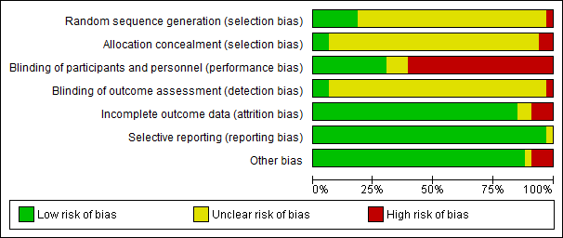

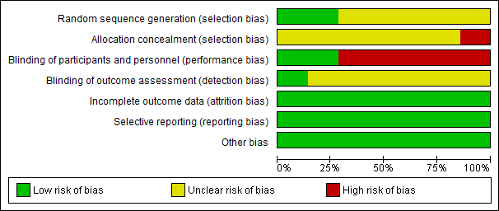

Figure 2. Risk of bias summary for included trials in the oats (top) and barley (below) meta-analyses

Evidence for β-glucan and blood cholesterol concentration
The literature search did not identify any study that reported the use of pure β-glucan from oats or barley. Similarly, no studies were identified that used otherwise identical foods that differed only in their β-glucan content. Just over half of the identified trials actually measured the β-glucan content of the test foods. Though oats and barley are natural sources of β-glucan, the levels of β-glucan varies depending on the plant variety and geographical origin of the grain, and can be altered during processing (Wood 2002). Some studies tested extracts which had been concentrated by chemical and physical techniques and so do not meet the specification in Standard 1.2.7 of ‘wholegrain’ oats or barley. Authors typically referred to these substances as β-glucan whereas in fact the maximum proportion of β-glucan in any of these tested foods was 36% (Biorklund et al. 2005), i.e. β-glucan was not the only available bioactive component.

It is perhaps not surprising that purified β-glucan studies were not available, given the difficultly of obtaining pure β-glucan from grains. Therefore, no studies that directly assessed the effects of β-glucan consumption without other types of dietary fibre on blood cholesterol concentration were available. Even by using trials with strata that differed in β-glucan content, it was not possible to determine if β-glucan is the only compound causing cholesterol lowering due to other confounders i.e. other types of dietary fibres. To show an exclusive causal link between β-glucan and a reduction in blood cholesterol, it would be necessary to include studies which used identical treatments, with or without pure β-glucan rather than the mixtures of fibres that have been tested to date.

A meta-analysis of 25 RCTs published between 1966 and 1996 showed that dietary soluble fibre, in general, from oat products, psyllium, pectin, and guar gum reduced total and LDL cholesterol by -0.045 and -0.057 mmol/L per gram of daily soluble fibre intake, respectively (Brown et al. 1999). However, the studies included by the authors were often foods that did not have adequate controls for drawing the conclusion that the soluble fibre was the only active component. A systematic review including 10 RCTs published between 1988 and 2005 suggested that wholegrain oats can reduce blood total and LDL cholesterol (Kelly et al. 2007). Although previous systematic reviews have linked the reduction in blood lipids with consuming oats, and other grains in some cases, this effect was ascribed exclusively to β-glucan in a systematic review by Whitehead et al. (2014). However, the foods included in the 28 RCTs in the review by Whitehead et al. (2014) were described by the authors as oatmeal, oat bran, oat flour, oat fibre or oat gum but not as pure β-glucan. The systematic review did not include wholegrain or rolled oats.

Evidence for the effect of dietary intake of oats on blood cholesterol concentration
Given the foregoing discussion, FSANZ considered the conditions for the relationship about β-glucan and blood cholesterol in Schedule 2 of Standard 1.2.7. Column 5 states: ‘the food must contain (a) one or more of the following oat or barley foods – (i) oat bran; (ii) wholegrain oats or (iii) wholegrain barley.’ Based on these conditions, FSANZ considered whether it would be possible to establish separate claims with oats or barley as the food or property of food, rather than β-glucan. Thus, separate meta-analyses across a subset of the studies identified by our original search strategy were conducted. Standard 1.2.7 permits the β-glucan claim on foods containing oats or barley as whole foods and does not permit claims on chemically concentrated or extracted forms of oats and barley. Therefore, we restricted our further analyses to include only studies that used oats and barley in the forms of these foods mentioned in Standard 1.2.7 and Section 1.1 of this report. This resulted in the exclusion of any studies that used chemically or enzymatically concentrated or extracted oat fibres (Vorster et al. 1986; Pick et al. 1996; Behall et al. 1997; Amundsen et al. 2003; Biorklund et al. 2005; Chen et al. 2006; Biorklund et al. 2008; Beck et al. 2010; Cugnet-Anceau et al. 2010; Ibrugger et al. 2013).

Scatterplots of the changes in the concentration of total and LDL cholesterol by the amount and type of oats consumed are provided in Figure 3. Figure 3 shows that the quantity of wholegrain oat products (other than bran) consumed ranged between 45 g and 109 g per day, whereas the quantity of oat bran consumed ranged between 20 g and 150 g per day. There is no apparent dose-response effect across these intake ranges. Figures 4 and 5 show forest plots obtained from the meta-analyses of oat consumption and total and LDL cholesterol, respectively.

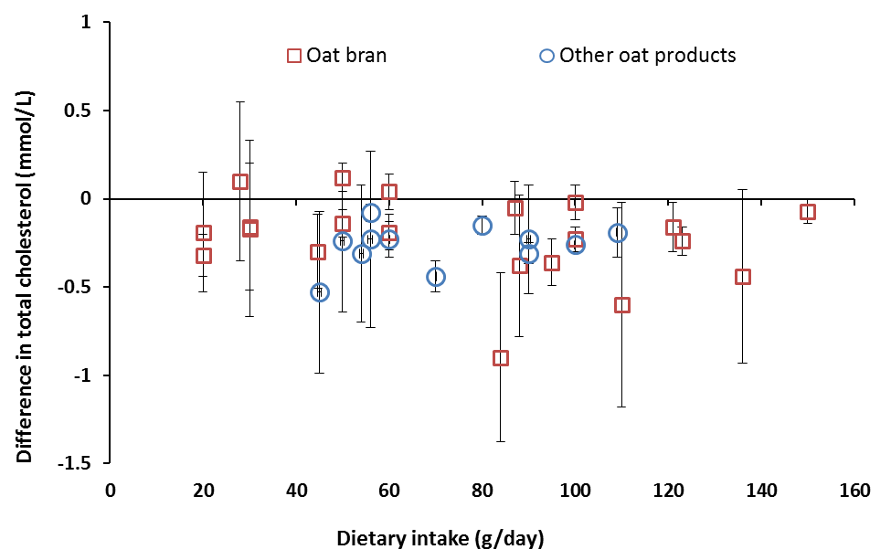

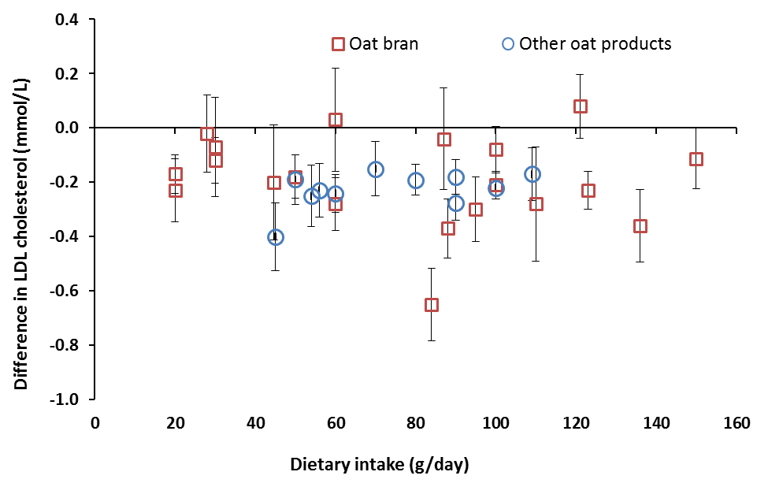

Figure 3. Differences (mean ± 95% CI) between intervention and control groups in blood total cholesterol (top) and LDL cholesterol (bottom) affected by the type and amount of consumed oat bran or other oat products

Total cholesterol
Overall, there was a change of -0.22 mmol/L in total cholesterol concentrations (95% CI:
-0.27, -0.17, P<0.00001, Figure 4) following consumption of wholegrain oats or oat bran. Heterogeneity, as indicated by I², was moderate (52%).

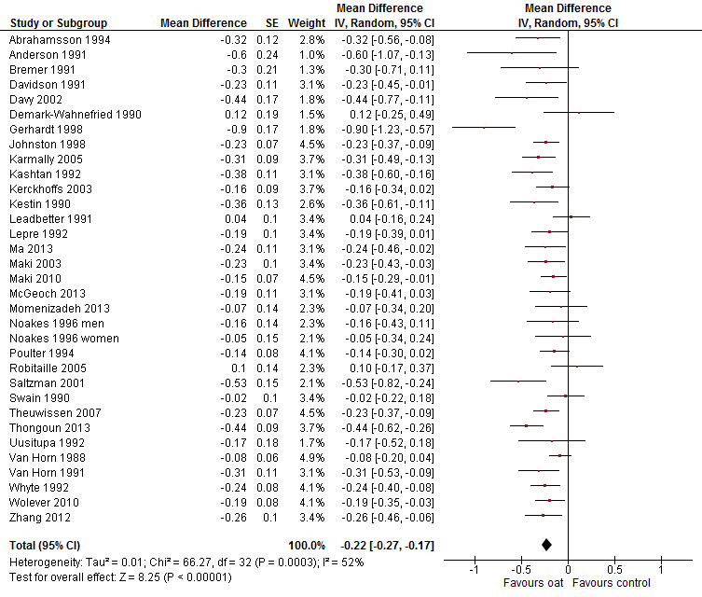

Figure 4. Forest plot for effects of consuming oats on total cholesterol concentration

LDL cholesterol
As with total cholesterol, consumption of oats reduced LDL cholesterol concentration, with an overall change of -0.21 mmol/L (95% CI: -0.24, -0.17, P<0.00001). Overall, heterogeneity was lower for changes in LDL concentration compared to total cholesterol concentration (I² = 16%).

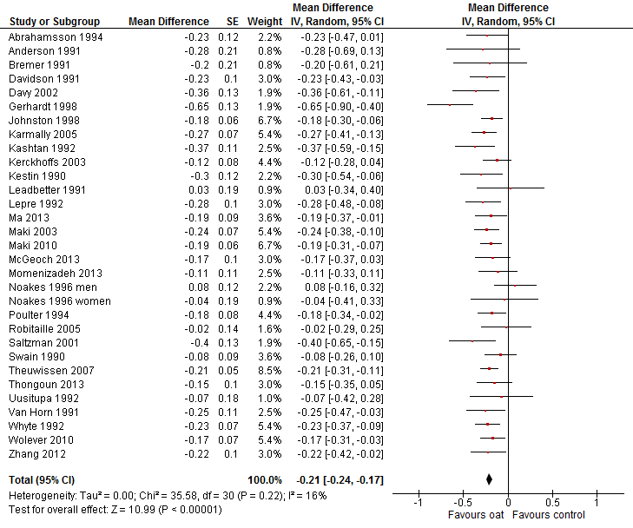

Figure 5. Forest plot for effects of consuming oats on LDL cholesterol concentration

HDL cholesterol
Consumption of oats did not result in a significant reduction in HDL cholesterol concentration (Figure 6). In fact, there was no effect (0 mmol/L, (95% CI: -0.01, 0.00, P = 0.32)) and the confidence interval excluded important effects. Heterogeneity for this analysis was low (I² = 36%).

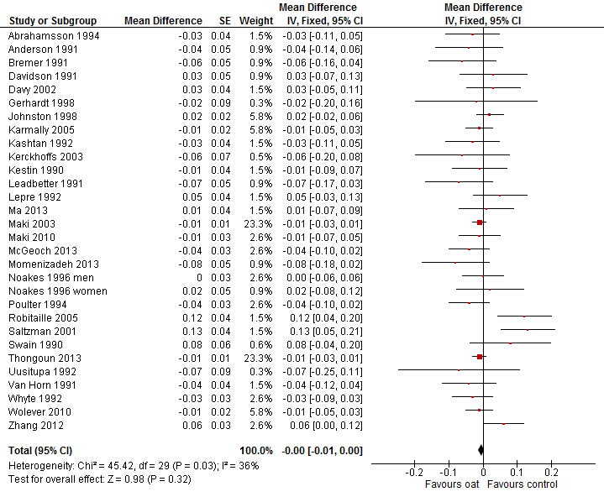

Figure 6. Forest plot for effects of consuming oats on HDL cholesterol concentration

Sub-group analyses

Baseline total cholesterol
The majority of trials were conducted in populations with hypercholesterolaemia (defined as ≥ 5.5 mmol/L baseline total cholesterol). However, there was no difference in the size of the effect of oats in reducing either total or LDL cholesterol concentrations according to baseline cholesterol status (p for sub-group difference >0.65, Table 3). Similarly, there was no sub-group difference for HDL by baseline cholesterol status.

Sex
Five of the included trials were conducted in males (Kestin et al. 1990; Anderson et al. 1991; Whyte et al. 1992; Noakes et al. 1996; Davy et al. 2002), and three were conducted in females (Abrahamsson et al. 1994; Noakes et al. 1996; Robitaille et al. 2005). The remainder of studies had participants from both sexes and did not report the data by sex. Despite showing significant reduction in total cholesterol and LDL cholesterol in the male’s sub-group, there were no significant differences between the sub-groups (Table 3).

Background diet
Background diets within trials were classed as either provided, well- or poorly-matched. The provided diets were matched for macro- and micronutrient content, and only differed by oat content. Some diets matched soluble and insoluble fibre intake, using other sources of dietary fibre, but others did not. Well-matched diets had less than 10% difference in saturated fat and dietary fibre intakes between the intervention and control groups, while poorly-matched studies had greater than 10% difference in the intake of these nutrients. Two studies were excluded from this sub-analysis as the background dietary intakes were not provided. Most strata showed significant decreases in total cholesterol and LDL cholesterol levels (Table 3). There was no significant sub-group effect for total, LDL or HDL cholesterol.

Funding source
The funding source of papers was classified as industry, government/university, or mixed funding, based on the acknowledgement of trial funding provided in the publications. In eight trials, the funding source was unclear. These trials were classified into the three defined strata according to author affiliations. There were significant decreases in total and LDL cholesterol concentration in trials funded by all three funding classifications. Importantly, there was no significant difference between the funding sub-groups on total, LDL or HDL cholesterol concentrations (Table 3).

Funding source by baseline total cholesterol levels
Sub-group analysis based on the baseline cholesterol concentration of participants (< 5.5 mmol/L are normal, ≥ 5.5 mmol/L are hypercholesterolaemic) according to the funding source (industry, government/university, or mixed funding) was conducted. Significant reductions in total and LDL cholesterol concentrations were observed in all trials, regardless of their sub-group, except for studies conducted by government/universities on people with normal blood cholesterol levels (Table 3). While HDL cholesterol concentrations significantly increased only in studies on normocholesterolaemic people funded by mixed sources, no other changes were detected in other sub-groups. There were no significant differences found between the sub-groups for their total or LDL cholesterol (Table 3).

Differences among the sub-groups for HDL cholesterol concentrations were significant (Table 3). Most strata had a mean result similar to the overall effect of 0 mmol/L (95% CI: -0.01, 0.00, P = 0.32) (i.e. no effect on HDL-cholesterol concentration) whereas one stratum had a statistically significant increase in HDL-cholesterol concentration (0.13 mmol/L in studies with mixed funding in normo-cholesterolaemic people; P = 0.001). This stratum also showed the largest reductions in total and LDL-cholesterol concentrations. Therefore this analysis does not indicate a bias in the results that would obscure an adverse effect.

Study quality
As described above (Section 2.2.4), a sub-group analysis based on study quality classifying papers as high or low quality depending on their risk of performance bias (blinding of participants and trial personnel) was conducted. More than half of the oats studies included in the meta-analysis were at high risk of performance bias. Performance bias assesses whether appropriate care has been taken to blind/mask the study participants and personnel working on the project to reduce the risk that external factors, such as knowledge of the intervention, will influence the outcome measures rather than the intervention itself.

Significant reductions in total and LDL cholesterol concentrations were observed in trials regardless of their quality and the magnitude of effect was slightly larger in the high quality studies compared with the low quality studies (Table 3). However, there were no significant sub-group effects on either total, LDL or HDL cholesterol concentrations (Table 3).

Publication bias
Visual inspection of funnel plots which identified studies by funding source indicated a low risk of publication bias (Figure 7), though there was some suggested publication bias within the government-funded and university-authored trials tending to report total cholesterol outcomes which favoured the oat group (Figure 7, top panel). However, the funnel plots for LDL and HDL cholesterol indicated publication bias was not present for these outcomes (Figure 7, middle and bottom panels).

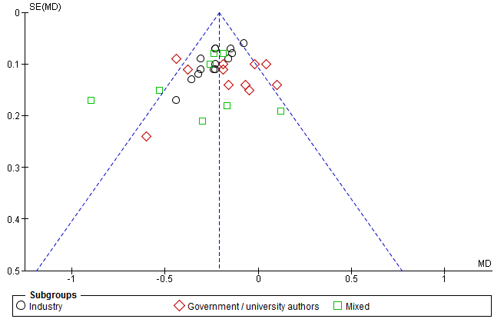

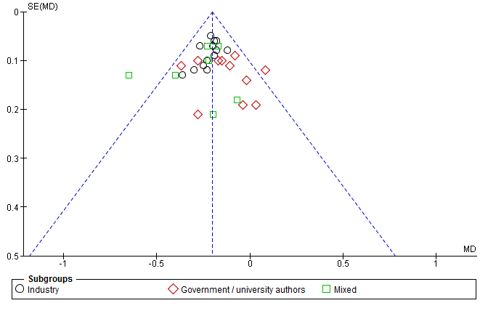

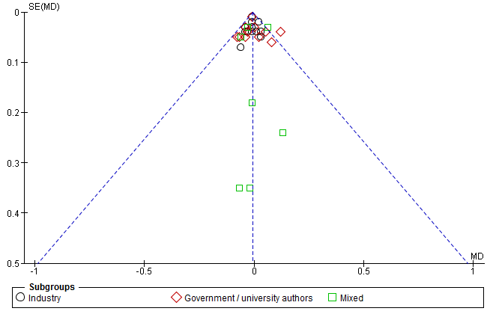

Figure 7. Funnel plots for total (top), LDL (middle) and HDL (bottom) cholesterol. Oats studies were identified by funding source/author affiliations (industry, government/university or mixed). Funnel plots were generated from fixed effects model as this plotted the 95% CI lines. MD; mean difference in cholesterol concentration in mmol/L.

Table 3: Results of sub-group analyses for total, LDL and HDL cholesterol concentration changes using random effects model from studies assessing the relationship between the consumption of oats and blood cholesterol concentration
Sub-group |  | No. strata | Total cholesterol  Mean difference [95% CI] | P | Total cholesterol  P-value Sub-group difference | LDL cholesterol  Mean difference (95% CI) | P | LDL cholesterol  P-value Sub-group difference | HDL cholesterol  Mean difference (95% CI) | P | HDL cholesterol  P-value Sub-group difference
Overall |  | 33/31/30¹ | -0.22  [-0.27, -0.17]  I² = 52% | <0.00001 | n/a | -0.20  [-0.24, -0.17]  I² = 16% | <0.00001 | n/a | 0.00  [-0.01, 0.00]  I² = 36% | 0.32 | n/a
Baseline total cholesterol | <5.5 | 10/9/ 9 | -0.21  [-0.31, -0.11]  I² = 57% | <0.0001 | 0.74 | -0.22  [-0.28, -0.15]  I² = 6% | <0.00001 | 0.68 | 0.02  [-0.01, 0.06]  I² =69% | 0.22 | 0.11
 | ≥5.5 | 23/22/21 | -0.22  [-0.27, -0.17]  I² = 50% | <0.00001 |  | -0.20  [-0.25, -0.16]  I² = 22% | <0.00001 |  | -0.01  [-0.02, 0.00]  I² = 0% | 0.17
Sex | Male | 5/5/5 | -0.29  [-0.40, -0.18]  I² = 0% | <0.00001 | 0.18 | -0.21  [-0.36, -0.06]  I² = 50% | 0.005 | 0.43 | -0.01  [-0.04, 0.02]  I² = 0% | 0.55 | 0.35
 | Female | 3/3/3 | -0.10  [-0.35, 0.16]  I² = 63% | 0.45 |  | -0.12  [-0.28, 0.04]  I² = 0% | 0.14 |  | 0.04  [-0.06, 0.13]  I² = 72% | 0.43
Back-ground diet | Provided | 4/4/4 | -0.38  [-0.52, -0.24]  I² = 13% | <0.00001 | 0.06 | -0.29  [-0.41, -0.18]  I² = 0% | <0.00001 | 0.46 | 0.02  [-0.06, 0.10]  I² = 72% | 0.62 | 0.83
 | Well matched | 20/ 19/18 | -0.20  [-0.25, -0.15]  I² = 34% | <0.00001 |  | -0.21  [-0.26, -0.17]  I² = 0% | <0.00001 |  | -0.01  [-0.03, 0.01]  I² = 45% | 0.57
 | Poorly matched | 9/8/8 | -0.23  [-0.37, -0.09]  I² = 71% | 0.001 |  | -0.22  [-0.34, -0.10]  I² = 67% | 0.0002 |  | -0.01  [-0.03, 0.02]  I² = 0% | 0.81

Funding source | Industry | 14/13/12 | -0.21  [-0.25, -0.16]  I² = 0% | <0.00001 | 0.17 | -0.21  [-0.25, -0.17]  I² = 0% | <0.00001 | 0.09 | -0.01  [-0.02, 0.01]  I² = 0% | 0.28 | 0.86
 | Govt/ university | 11/11/11 | -0.17  [-0.24, -0.10]  I² = 64% | 0.006 |  | -0.14  [-0.21, -0.07]  I² = 20% | 0.0006 |  | -0.01  [-0.02, 0.01]  I² = 51% | 0.42
 | Mixed | 8/7/7 | -0.27  [-0.36, -0.19]  I² = 69% | 0.002 |  | -0.25  [-0.33, -0.18]  I² = 62% | <0.00001 |  | 0.00  [-0.03, 0.04]  I² = 11% | 0.84
Funding source per baseline total cholesterol | Industry <5.5 | 6/5/5 | -0.24  [-0.34, -0.13]  I² = 42% | <0.0001 | 0.09 | -0.25  [-0.33, -0.17]  I² = 0% | <0.00001 | 0.15 | -0.01  [-0.02, 0.01]  I² = 0% | 0.32 | 0.02
 | Industry ≥5.5 | 8/8/7 | -0.21  [-0.27, -0.15]  I² = 0% | <0.00001 |  | -0.20  [-0.25, -0.15]  I² = 0% | <0.00001 |  | -0.01  [-0.03, 0.02]  I² = 0% | 0.65
 | Govt/ university <5.5 | 3/3/3 | -0.05  [-0.21, 0.10]  I² = 30% | 0.53 |  | -0.05  [-0.21, 0.10]  I² = 30% | 0.53 |  | 0.03  [-0.02, 0.07]  I² = 82% | 0.24
 | Govt/ university ≥5.5 | 8/8/8 | -0.21  [-0.36, -0.07]  I² = 65% | 0.004 |  | -0.21  [-0.36, -0.07]  I² = 65% | 0.004 |  | -0.01  [-0.03, 0.01]  I² = 0% | 0.19
 | Mixed <5.5 | 1/1/1 | -0.53  [-0.82, -0.24]  I² = n/a | 0.0004 |  | -0.40  [-0.65, -0.15]  I² = n/a | 0.002 |  | 0.13  [0.05, 0.21]  I² = n/a | 0.001
 | Mixed ≥5.5 | 7/6/6 | -0.27  [-0.44, -0.10]  I² = 69% | 0.002 |  | -0.26  [-0.39, -0.12]  I² = 58% | <0.00001 |  | 0.00  [-0.03, 0.02]  I² = 31% | 0.32
Study quality | High | 14/14/13 | -0.27  [-0.34, -0.20]  I² = 35% | <0.00001 | 0.12 | -0.24  [-0.29, -0.19]  I² = 16% | <0.00001 | 0.07 | -0.01  [-0.02, 0.01]  I² = 5% | 0.31 | 0.62
 | Low | 19/17/17 | -0.19  [-0.26, -0.11]  I² = 57% | <0.00001 |  | -0.18  [-0.22, -0.13]  I² = 4% | <0.00001 |  | -0.02  [-0.04, 0.01]  I² = 0% | 0.19

¹33 strata reported total cholesterol, of which 31 reported LDL cholesterol concentration and 30 reported HDL cholesterol concentration

Evidence for the effect of dietary intake of barley on blood cholesterol concentration
A scatterplot of the changes in the concentration of total and LDL cholesterol by the amount of consumed barley is provided in Figure 8 followed by detailed effect estimate meta-analyses (Figures 9 and 10). Figure 8 shows that the quantity of barley consumed ranged between 30 g and 175 g per day.

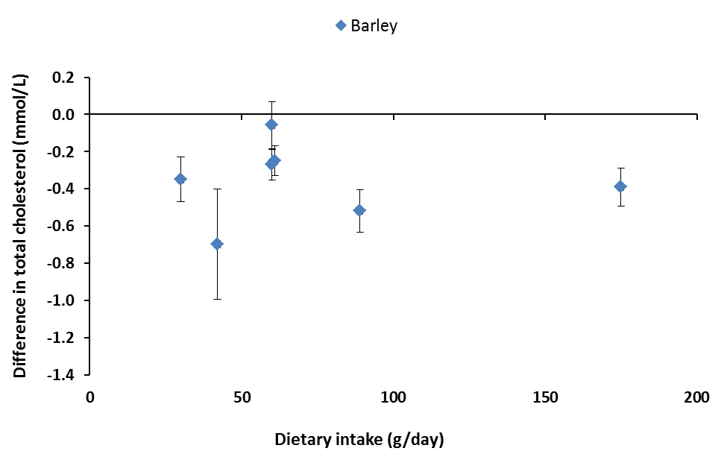

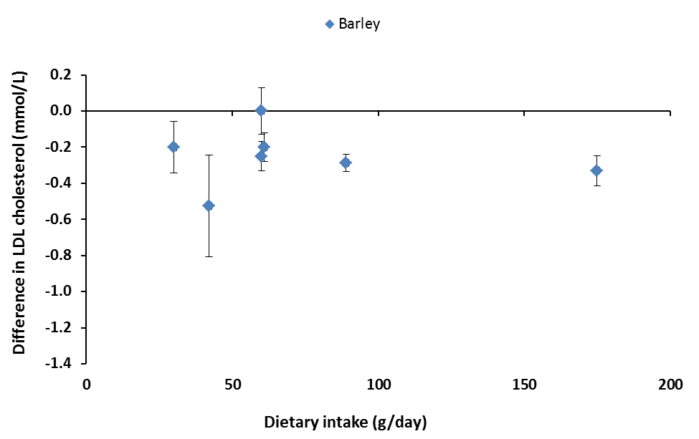

Figure 8. Differences (mean ± 95% CI) between intervention and control groups in blood total cholesterol (top) and LDL cholesterol (bottom) affected by the amount of consumed barley.

Total cholesterol
Consumption of barley resulted in a significant change in total cholesterol (-0.32 mmol/L, 95% CI: -0.42, -0.21, P<0.00001, Figure 9). Heterogeneity, as indicated by I², was low at 40%.

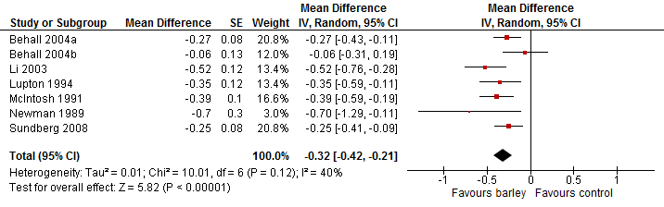

Figure 9. Forest plot for effects of consuming barley on total cholesterol concentration.

LDL cholesterol
Intake of barley reduced LDL cholesterol significantly (-0.25 mmol/L; 95% CI: -0.32, -0.18, P<0.00001, Figure 10). There was no important heterogeneity (I² = 12%) which means that variation among study results can be attributed to chance.

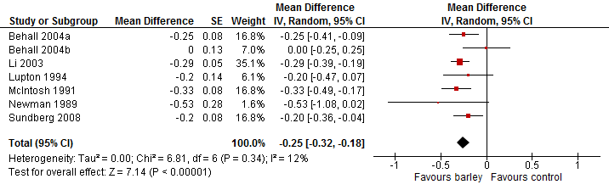

Figure 10. Forest plot for effects of consuming barley on LDL cholesterol concentration.

HDL cholesterol
In contrast with total and LDL cholesterol, consumption of barley had no significant effect (P = 0.08) on HDL cholesterol concentration (Figure 11).

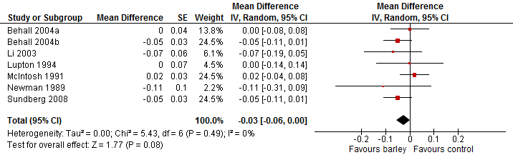

Figure 11. Forest plot for effects of consuming barley on HDL cholesterol concentration

Sub-group analyses and publication bias
Five of the seven strata were conducted in people with hypercholesterolaemic concentrations (mean group baseline total cholesterol ≥5.5 mmol/L). The magnitude of effect on total cholesterol concentration was twice as large in those with normal cholesterol concentrations and this sub-group difference was statistically significant (Table 4). However, these results should be interpreted with caution, given the low number of studies in each sub-group. In particular only 24 people with normal cholesterol concentrations were tested, and because there were no sub-group differences for LDL and HDL concentrations (Table 4) by baseline cholesterol concentration.

A sub-group analysis of study quality was conducted, classifying studies as high or low quality based on their risk of performance bias (blinding of participants and trial personnel). Results from high quality studies had no significant changes in total or HDL cholesterol concentration but changes in LDL cholesterol were significant (Table 4). Five out of the seven studies included in the meta-analysis were at high risk of performance bias. The five low quality studies showed significant reductions in total and LDL cholesterol (Table 4). Similar magnitudes of reduction were observed in both high and low quality groups. However, there was no significant difference between the subgroups for total, LDL or HDL cholesterol concentrations (Table 4).

Due to the low number of studies included in the barley meta-analysis, we did not use funnel plots to assess publication bias but used visual inspection of forest plots. There did not appear to be any apparent publication bias.

Table 4: Results of sub-group analyses for total, LDL and HDL cholesterol concentration changes using random effects model from studies assessing the relationship between consumption of barley and blood cholesterol concentration
Sub-group |  | No. strata | Total cholesterol  Mean difference (95% CI) | P | Total cholesterol  P-value Sub-group difference | LDL cholesterol  Mean difference (95% CI) | P | LDL cholesterol  P-value Sub-group difference | HDL cholesterol  Mean difference (95% CI) | P | HDL cholesterol  P-value Sub-group difference
Overall |  | 7 | -0.32  [-0.42, -0.21]  I² = 40% | <0.00001 | n/a | -0.25  [-0.32, -0.18]  I² = 12% | <0.00001 | n/a | -0.03  [-0.06, 0.00]  I² = 0% | 0.49 | n/a
Baseline total cholesterol | <5.5 | 2 | -0.54  [-0.76, -0.33]  I² = 0% | <0.00001 | 0.02 | -0.30  [-0.39, -0.20]  I² = 0% | <0.00001 | 0.28 | -0.08  [-0.18, 0.02]  I² =0% | 0.12 | 0.27
 | ≥5.5 | 5 | -0.27  [-0.36, -0.18]  I² = 12% | <0.00001 |  | -0.22  [-0.32, -0.13]  I² = 19% | <0.00001 |  | -0.02  [-0.05, 0.01]  I² = 2% | 0.49
Study quality | High | 2 | -0.38  [-0.78, 0.02]  I² = 52% | 0.06 | 0.78 | -0.26  [-0.50, -0.01]  I² = 22% | 0.04 | 0.99 | -0.05  [-0.11, 0.00]  I² = 0% | 0.06 | 0.24
 | Low | 5 | -0.32  [-0.45, -0.19]  I² = 48% | <0.00001 |  | -0.25  [-0.34, -0.17]  I² = 25% | <0.00001 |  | -0.02  [-0.05, 0.02]  I² = 0% | 0.49

n/a not applicable

Weight of evidence
Fifty-seven strata were included in the systematic review. All 57 strata used oats, barley or fibre/β-glucan extracted/concentrated from oats or barley and measured blood cholesterol concentration. Not all of the included studies measured the quantity of β-glucan that participants consumed. No studies were identified that administered pure β-glucan extracted from oats or barley, or examined naturally occurring differences in β-glucan between oat or barley cultivars. This resulted in a lack of evidence to support exclusively attributing the relationship between oats or barley and blood cholesterol concentration to β-glucan. Whilst Standard 1.2.7 contains a pre-approved high level health claim for the relationship between β-glucan from oats or barley and reductions in blood cholesterol, our systematic review suggests that the currency of this relationship cannot be determined from the current scientific literature.

As Standard 1.2.7 refers to wholegrain oats, oatbran and wholegrain barley, we conducted two separate meta-analyses to assess the relationship between oats and blood cholesterol and barley and blood cholesterol. We only included studies which used non-concentrated forms of oats or barley, as this is what is referenced in Standard 1.2.7 and defined in Section 1.1 (Food or property of food). These results cannot necessarily be extrapolated to other forms, i.e. concentrates, because the physiochemical properties of oat and barley soluble fibre are altered when extracted. These two meta-analyses showed that dietary consumption of oats or barley significantly decreased total and LDL cholesterol concentration regardless of the baseline total cholesterol.

Assessment of body of evidence

Consistency of relationship
The consistency of the effects of pure β-glucan from oats or barley on total, LDL or HDL cholesterol concentrations in blood could not be assessed because there were no reported trials which would allow the effect of β-glucan to be separated from the effects of other components in the food products.

FSANZ considered there was no important inconsistency in the evidence base for the effects of oats on total and LDL cholesterol concentrations and barley on total and LDL cholesterol concentrations, as the 95% confidence intervals for the overall effect estimates did not reach zero, and overlapped with almost all studies. The majority of RCTs showed decreased total and LDL cholesterol concentration after consumption of oats. Heterogeneity was unimportant for LDL cholesterol following oats consumption which suggests that the variation in results among trials can be attributed to chance rather than to some unexplored factor. This was regarded as a more important result than the moderate heterogeneity for total cholesterol. In addition, most studies had an effect and so inconsistency related more to the magnitude of effect than presence of effect. Similarly, all strata showed decreased total cholesterol and most strata showed decreased LDL cholesterol concentration after consumption of barley and the 95% confidence intervals for the overall effect estimates did not reach zero, and overlapped with all studies.

Causality
RCTs are a strong study design for detecting causal relationships. The literature search did not identify any RCTs that assessed the effects of consumption of pure β-glucan or naturally occurring differences in β-glucan content in oats or barley (e.g. genetic variants) on blood cholesterol concentration. Therefore any effects in these studies cannot be exclusively attributed to β-glucan and a causal relationship cannot be demonstrated. FSANZ concluded that the relationship between β-glucan and blood cholesterol concentration is non-assessable (Appendix 6).

The meta-analysis of 33 oat intervention strata showed a consistent reduction in total and LDL cholesterol concentrations across the studies. The meta-analysis of seven studies of barley showed a consistent reduction in total and LDL across studies, albeit, with serious imprecision due to the low number of participants. The overall body of evidence was considered to be at low risk of bias for both meta-analyses. The outcome was measured directly and the confidence intervals are tight and, for total and LDL cholesterol concentrations, exclude the null effect. There was no sub-group difference by baseline cholesterol status or by study quality. Therefore, it can be concluded the relationship between the consumption of oats and the reduction in total and LDL cholesterol concentration is present in high quality studies and has a ‘High’ degree of certainty (Appendix 7). The relationship between the consumption of barley and the reduction in LDL cholesterol concentration is present in high quality studies. However, due to the serious imprecision in the body of evidence caused by the low number of participants, the relationship was rated as ‘Moderate’ degree of certainty (Appendix 8).

There was no effect of oats or barley on HDL concentrations or important variation among the sub-groups that would suggest that an effect on HDL-concentration existed. Therefore, it was concluded that there was a ‘High’ degree of certainty that oats have no effect on HDL cholesterol concentration. Because of serious imprecision in the body of evidence caused by the low number of participants, there was a ‘Moderate’ degree of certainty that barley has no effect on HDL cholesterol concentration.

Plausibility
Current hypotheses suggest three different mechanisms by which oats and barley may alter blood cholesterol concentration. When consumed, soluble fibres (including β-glucan) increase viscosity within the gastrointestinal tract and can coat the mucosal layer, thereby slowing absorption of nutrients from the gut (reviewed in Othman et al. 2011). This may reduce cholesterol absorption and bile acid re-uptake. Reduced bile acid re-uptake leads to enhanced bile acid synthesis in the liver. As cholesterol is a precursor of bile acids, this may reduce hepatic cholesterol stores, and, ultimately, concentration of cholesterol within the blood. The solubility and molecular weight of β-glucan are important factors in determining its viscosity. In addition to effects on viscosity, β-glucan and other soluble fibres undergo anaerobic fermentation in the colon, generating short chain fatty acids (Kumar et al. 2012). These short chain fatty acids may inhibit cholesterol synthesis, which could lead to decreases in blood cholesterol concentration.

Although oats and barley have relatively similar macro- and micronutrient profiles in general, oats contain less fibre, more protein and more fat than barley. Oats also contain higher levels of unsaturated fatty acids compared to barley. Consumption of unsaturated fatty acids may contribute to the observed cholesterol-lowering effect of oats. In a study of various cereals, the β-glucan content of oats and barley was approximately 5% w/w, while the content in wheat was less than 1% w/w (Shewry et al. 2013). However, it is important to note that the β-glucan content of oats and barley is highly dependent on grain cultivar and geographical region (Wood 2002).

It is likely that additional factors within oats and barley may also have cholesterol-lowering properties, or that it is necessary for the β-glucan to be in its natural state for it to contribute to a reduction in blood cholesterol. For example, arabinoxylan, another non-starch polysaccharide, is found at similar levels to β-glucan in the grain endosperm of oats and barley (Izydorczyk and Dexter 2008). However, in many papers it is unclear whether arabinoxylan is a component of the fibre extract and whether it has been controlled for in the extract/study design. Therefore there are a variety of possible components in oats and barley, including β-glucan, which make the observed results plausible. FSANZ cannot assign the cholesterol lowering effects of oats and barley to β-glucan unequivocally.

Applicability to Australia and New Zealand

Intake required for effect
The included trials used a daily quantity from 20 g to 150 g of oats (20 g and 150 g of oat bran or 45 g to 109 g (dry weight) of other oat products), or 30 g and 175 g of barley to modify blood cholesterol concentrations. There was an effect across the range of tested intakes (Figures 3 and 8) although not proportional to the consumed amount. The median serving size of hot porridge type cereals among consumers was 218 g (as prepared) in adults in Australia (Australia Bureau of Statistics 2014) which equates to approximately 40 g (dry weight).

Target population
Nine oat trials and one barley trial were conducted in Australia and New Zealand. Other trials were conducted in North America, Europe, Asia and Africa. These studies indicated the applicability of the results to Australian and New Zealand populations.

Only one trial testing oats was identified in children; they were 6-14 year olds with hypercholesterolaemia (Maki et al. 2003). The results of this trial were similar to those of the combined set of studies (Figures 4-6). No studies tested barley in children.

Adverse effects
Lowering total and LDL cholesterol concentration following the consumption of oats or barley did not lead to a reduction in HDL cholesterol concentration, meaning that no significant adverse effect on blood lipids has been identified from consuming these foods.

More general adverse effects were gastrointestinal symptoms such as bloating, nausea, flatulence and a feeling of ‘fullness’. These effects are consistent with increased fibre intake, and were commonly reported in control groups as well.

Conclusion
Despite the inclusion of 54 RCTs (57 strata) in the review it was not possible to assess the relationship between β-glucan and blood cholesterol. However, separate meta-analyses were conducted for oats that included 33 strata and for barley that included 7 strata. In conclusion, the body of evidence gives a ‘High’ degree of certainty for the relationship between the consumption of oats and decreased total and LDL cholesterol concentration. The body of evidence gives a ‘Moderate’ degree of certainty for the relationship between the consumption of barley and decreased total and LDL cholesterol concentration.

Acknowledgment
We acknowledge the permission from The Cochrane Collaboration to use the Review Manager software.

References
Abrahamsson L, Goranzon H, Karlstrom B, Vessby B, Aaman P (1994) Metabolic effects of oat bran and wheat bran in healthy women. Scan J Nutr 38(1):5–10
Abumweis SS, Jew S, Ames NP (2010) β-glucan from barley and its lipid-lowering capacity: A meta-analysis of randomized, controlled trials. Eur J Clin Nutr 64(12):1472–1480
AIHW (2012) Australia's health 2012. AIHW, Canberra
Amundsen AL, Haugum B, Andersson H (2003) Changes in serum cholesterol and sterol metabolites after intake of products enriched with an oat bran concentrate within a controlled diet. Scan J Nutr 47(2):68–74
Anderson JW, Gilinsky NH, Deakins DA, Smith SF, O'Neal DS, Dillon DW, Oeltgen PR (1991) Lipid responses of hypercholesterolemic men to oat-bran and wheat-bran intake. Am J Clin Nutr 54(4):678–683
Australia Bureau of Statistics (2014) Australian Health Survey: Nutrition First Results-Foods and Nutrients, 2011-12.
http://www.abs.gov.au/ausstats/abs@.nsf/Lookup/by%20Subject/4364.0.55.007~2011-12~Main%20Features~Key%20Findings~1. Accessed 13 March 2015
Beck EJ, Tapsell LC, Batterham MJ, Tosh SM, Huang XF (2010) Oat beta-glucan supplementation does not enhance the effectiveness of an energy-restricted diet in overweight women. Br J Nutr 103(8):1212–1222
Behall KM, Scholfield DJ, Hallfrisch J (1997) Effect of beta-glucan level in oat fiber extracts on blood lipids in men and women. J Am Coll Nutr 16(1):46–51
Behall KM, Scholfield DJ, Hallfrisch J (2004a) Diets containing barley significantly reduce lipids in mildly hypercholesterolemic men and women. Am J Clin Nutr 80(5):1185–1193
Behall KM, Scholfield DJ, Hallfrisch J (2004b) Lipids significantly reduced by diets containing barley in moderately hypercholesterolemic men. J Am Coll Nutr 23(1):55–62
Biorklund M, Holm J, Onning G (2008) Serum lipids and postprandial glucose and insulin levels in hyperlipidemic subjects after consumption of an oat beta-glucan-containing ready meal. Ann Nutr Metab 52(2):83–90
Biorklund M, van RA, Mensink RP, Onning G (2005) Changes in serum lipids and postprandial glucose and insulin concentrations after consumption of beverages with beta-glucans from oats or barley: A randomised dose-controlled trial. Eur J Clin Nutr 59(11):1272–1281
Braaten JT, Wood PJ, Scott FW, Wolynetz MS, Lowe MK, Bradley-White P, Collins MW (1994) Oat beta-glucan reduces blood cholesterol concentration in hypercholesterolemic subjects. Eur J Clin Nutr 48(7):465–474
Bremer JM, Scott RS, Lintott CJ (1991) Oat bran and cholesterol reduction: evidence against specific effect. Aust N Z J Med 21(4):422–426
Brown L, Rosner B, Willett WW, Sacks FM (1999) Cholesterol-lowering effects of dietary fiber: a meta-analysis. Am J Clin Nutr 69(1):30–42
Brussaard JH, Katan MB, Groot PHE, Havekes LM, Hautvast JGAJ (1982) Serum lipoproteins of healthy persons fed a low-fat diet or a polyunsaturated fat diet for three months: a comparison of two cholesterol-lowering diets. Atherosclerosis 42:205–219
Chen J, He J, Wildman RP, Reynolds K, Streiffer RH, Whelton PK (2006) A randomized controlled trial of dietary fiber intake on serum lipids. Eur J Clin Nutr 60(1):62–68
Cugnet-Anceau C, Nazare JA, Biorklund M, Le CE, Sassolas A, Sothier M, Holm J, Landin-Olsson M, Onning G, Laville M, Moulin P (2010) A controlled study of consumption of beta-glucan-enriched soups for 2 months by type 2 diabetic free-living subjects. Br J Nutr 103(3):422–428
Davidson MH, Dugan LD, Burns JH, Bova J, Story K, Drennan KB (1991) The hypocholesterolemic effects of beta-glucan in oatmeal and oat bran. A dose-controlled study. Journal of the American Medical Association 265(14):1833–1839
Davy BM, Davy KP, Ho RC, Beske SD, Davrath LR, Melby CL (2002) High-fiber oat cereal compared with wheat cereal consumption favorably alters LDL-cholesterol subclass and particle numbers in middle-aged and older men. Am J Clin Nutr 76(2):351–358
Decker EA, Rose DJ, Stewart D (2014) Processing of oats and the impact of processing operations on nutrition and health benefits. Br J Nutr 112 Suppl 2:S58–S64
Demark-Wahnefried N, Bowering J, Cohen PS (1990) Reduced serum cholesterol with dietary change using fat-modified and oat bran supplemented diets. J Am Diet Assoc 90(2):223–229
Demonty I, Ras RT, van der Knaap HC, Duchateau GS, Meijer L, Zock PL, Geleijnse JM, Trautwein EA (2009) Continuous dose-response relationship of the LDL-cholesterol-lowering effect of phytosterol intake. J Nutr 139(2):271–284
EFSA (2009) Scientific Opinion on the substantiation of health claims related to beta-glucans and maintenance of normal blood cholesterol concentrations (ID 754, 755, 757, 801, 1465, 2934) and maintenance or achievement of a normal body weight (ID 820, 823) pursuant to Article 13(1) of Regulation (EC) No 1924/20061. EFSA Journal 7(9):1254
EFSA (2010) Scientific Opinion on the substantiation of a health claim related to oat beta-glucan and lowering blood cholesterol and reduced risk of (coronary) heart disease pursuant to Article 14 of Regulation (EC) No 1924/20061. EFSA Journal 8(12):1885
EFSA (2011a) Scientific Opinion on the substantiation of health claims related to beta-glucans from oats and barley and maintenance of normal blood LDL-cholesterol concentrations (ID 1236, 1299), increase in satiety leading to a reduction in energy intake (ID 851, 852), reduction of post-prandial glycaemic responses (ID 821, 824), and "digestive function" (ID 850) pursuant to Article 13(1) of Regulation (EC) No 1924/20061. EFSA Journal 9(6):2207
EFSA (2011b) Scientific Opinion on the substantiation of a health claim related to barley beta-glucans and lowering of blood cholesterol and reduced risk of (coronary) heart disease pursuant to Article 14 of Regulation (EC) No 1924/20061. EFSA Journal 9(12):2471
FSANZ (2010) Consideration of the effect of a 1:1 isomer mix of conjugated linoleic acid on HDL- and LDL-cholesterol levels (Application A1005). Supporting document 1. FSANZ, Canberra
Gerhardt AL, Gallo NB (1998) Full-fat rice bran and oat bran similarly reduce hypercholesterolemia in humans. J Nutr 128(5):865–869
Guillon F, Champ M (2000) Structural and physical properties of dietary fibres, and consequences of processing on human physiology. Food Res Int 33(3−4):233–245
Health Canada (2010) Summary of Assessment of a Health Claim about Oat Products and Blood Cholesterol Lowering.
http://www.hc-sc.gc.ca/fn-an/label-etiquet/claims-reclam/assess-evalu/oat-avoine-eng.php. Accessed 12 May 2014
Health Canada (2012) Summary of Health Canada's Assessment of a Health Claim about Barley Products and Blood Cholesterol Lowering.
http://www.hc-sc.gc.ca/fn-an/label-etiquet/claims-reclam/assess-evalu/barley-orge-eng.php. Accessed 12 May 2014
Higgins JP, Green S (2011) Cochrane handbook for systematic reviews of interventions. 5.1.0 ed, The Cochrane Collaboration,
Ibrugger S, Kristensen M, Poulsen MW, Mikkelsen MS, Ejsing J, Jespersen BM, Dragsted LO, Engelsen SB, Bugel S (2013) Extracted oat and barley beta-glucans do not affect cholesterol metabolism in young healthy adults. J Nutr 143(10):1579–1585
Izydorczyk MS, Dexter JE (2008) Barley ß-glucans and arabinoxylans: Molecular structure, physicochemical properties, and uses in food products-a Review. Food Res Int 41(9):850–868
Johnston L, Reynolds HB, Hunninghake DB, Schultz K, Westereng B (1998) Cholesterol-lowering benefits of a whole grain oat ready to eat cereal. Nutrition in Clinical Care;(1):6–12
Karmally W, Montez MG, Palmas W, Martinez W, Branstetter A, Ramakrishnan R, Holleran SF, Haffner SM, Ginsberg HN (2005) Cholesterol-lowering benefits of oat-containing cereal in hispanic Americans. J Am Diet Assoc 105(6):967–970
Kashtan H, Stern HS, Jenkins DJ, Jenkins AL, Hay K, Marcon N, Minkin S, Bruce WR (1992) Wheat-bran and oat-bran supplements' effects on blood lipids and lipoproteins. Am J Clin Nutr 55(5):976–980
Kelly SA, Summerbell CD, Brynes A, Whittaker V, Frost G (2007) Wholegrain cereals for coronary heart disease. Cochrane Database of Systematic Reviews(2):CD005051
Keogh GF, Cooper GJS, Mulvey TB, McArdle BH, Coles GD, Monro JA, Poppitt SD (2003) Randomized controlled crossover study of the effect of a highly beta-glucan-enriched barley on cardiovascular disease risk factors in mildly hypercholesterolemic men. Am J Clin Nutr 78(4):711–718
Kerckhoffs DA, Hornstra G, Mensink RP (2003) Cholesterol-lowering effect of beta-glucan from oat bran in mildly hypercholesterolemic subjects may decrease when beta-glucan is incorporated into bread and cookies. Am J Clin Nutr 78(2):221–227
Kestin M, Moss R, Clifton PM, Nestel PJ (1990) Comparative effects of three cereal brans on plasma lipids, blood pressure, and glucose metabolism in mildly hypercholesterolemic men. Am J Clin Nutr 52(4):661–666
Kim HJ, White PJ (2013) Impact of the molecular weight, viscosity, and solubility of beta-glucan on in vitro oat starch digestibility. J Agric Food Chem 61(13):3270–3277
Kumar V, Sinha AK, Makkar HP, de BG, Becker K (2012) Dietary roles of non-starch polysaccharides in human nutrition: a review. Crit Rev Food Sci Nutr 52(10):899–935
Leadbetter J, Ball MJ, Mann JI (1991) Effects of increasing quantities of oat bran in hypercholesterolemic people. Am J Clin Nutr 54(5):841–845
Lepre F, Crane S (1992) Effect of oatbran on mild hyperlipidaemia. Med J Aust 157(5):305–308
Li J, Kaneko T, Qin LQ, Wang J, Wang Y (2003) Effects of barley intake on glucose tolerance, lipid metabolism, and bowel function in women. Nutrition 19(11-12):926–929
Limberger-Bayer VM, de FA, Chan A, Oro T, Ogliari PJ, Barreto PL (2014) Barley β-glucans extraction and partial characterization. Food Chem 154:84–89
Lupton JR, Robinson MC, Morin JL (1994) Cholesterol-lowering effect of barley bran flour and oil. J Am Diet Assoc 94(1):65–70
Ma X, Gu J, Zhang Z, Jing L, Xu M, Dai X, Jiang Y, Li Y, Bao L, Cai X, Ding Y, Wang J, Li Y, Li Y (2013) Effects of Avena nuda L. on metabolic control and cardiovascular disease risk among Chinese patients with diabetes and meeting metabolic syndrome criteria: secondary analysis of a randomized clinical trial. Eur J Clin Nutr
Maki KC, Davidson MH, Ingram KA, Veith PE, Bell M, Gugger E (2003) Lipid responses to consumption of a beta-glucan containing ready-to-eat cereal in children and adolescents with mild-to-moderate primary hypercholesterolemia. Nutrition Research 23(11):1527–1535
Maki KC, Beiseigel JM, Jonnalagadda SS, Gugger CK, Reeves MS, Farmer M, V, Kaden VN, Rains TM (2010) Whole-Grain Ready-to-Eat Oat Cereal, as Part of a Dietary Program for Weight Loss, Reduces Low-Density Lipoprotein Cholesterol in Adults with Overweight and Obesity More than a Dietary Program Including Low-Fiber Control Foods. J Am Diet Assoc 110(2):205–214
Manzi P, Pizzoferrato L (2000) Beta-glucans in edible mushrooms. Food Chem 68(3):315–318
McGeoch SC, Johnstone AM, Lobley GE, Adamson J, Hickson K, Holtrop G, Fyfe C, Clark LF, Pearson DW, Abraham P, Megson IL, Macrury SM (2013) A randomized crossover study to assess the effect of an oat-rich diet on glycaemic control, plasma lipids and postprandial glycaemia, inflammation and oxidative stress in Type 2 diabetes. Diabetic Medicine: a journal of the British Diabetic Association 30(11):1314–1323
McIntosh GH, Whyte J, McArthur R, Nestel PJ (1991) Barley and wheat foods: Influence on plasma cholesterol concentrations in hypercholesterolemic men. Am J Clin Nutr 53(5):1205–1209
Mensink RP, Katan MB (1987) Effect of monounsaturated fatty acids versus complex carbohydrates on high-density lipoproteins in healthy men and women. Lancet 1:122–125
Miller WG, Myers GL, Sakurabayashi I, Bachmann LM, Caudill SP, Dziekonski A, Edwards S, Kimberly MM, Korzun WJ, Leary ET, Nakajima K, Nakamura M, Nilsson G, Shamburek RD, Vetrovec GW, Warnick GR, Remaley AT (2010) Seven direct methods for measuring HDL and LDL cholesterol compared with ultracentrifugation reference measurement procedures. Clin Chem 56(6):977–986
Momenizadeh A, Heidari R, Sadeghi M, Tabesh F, Ekramzadeh M, Haghighatian Z, Golshahi J, Baseri M (2014) Effects of oat and wheat bread consumption on lipid profile, blood sugar, and endothelial function in hypercholesterolemic patients: A randomized controlled clinical trial. ARYA Atheroscler 10(5):259–265
Newman RK, Newman CW (2008) Barley for food and health: Science, technology, and products. 1st ed, John Wiley & Sons, Hoboken, N.J., USA
Newman RK, Lewis SE, Newman CW, Boik RJ, Ramage RT (1989) Hypocholesterolemic effect of barley foods on healthy men. Nutrition Reports International 39(4):749–760
Noakes M, Clifton PM, Nestel PJ, Leu R, McIntosh G (1996) Effect of high amylose starch and oat bran on metabolic variables and bowel function in subjects with hypertriglyceridemia. Am J Clin Nutr 64(6):944–951
Onning G, Wallmark A, Persson M, Akesson B, Elmstahl S, Oste R (1999) Consumption of oat milk for 5 weeks lowers serum cholesterol and LDL cholesterol in free-living men with moderate hypercholesterolemia. Ann Nutr Metab 43(5):301–309
Othman RA, Moghadasian MH, Jones PJ (2011) Cholesterol-lowering effects of oat beta-glucan. Nutr Rev 69(6):299–309
Pick ME, Hawrysh ZJ, Gee M, I, Toth E, Garg ML, Hardin RT (1996) Oat bran concentrate bread products improve long-term control of diabetes: A pilot study. J Am Diet Assoc 96(12):1254–1261
Poulter N, Chang CL, Cuff A, Poulter C, Sever P, Thom S (1994) Lipid profiles after the daily consumption of an oat-based cereal: A controlled crossover trial. Am J Clin Nutr 59(1):66–69
Robitaille J, Fontaine-Bisson B, Couture P, Tchernof A, Vohl MC (2005) Effect of an oat bran-rich supplement on the metabolic profile of overweight premenopausal women. Ann Nutr Metab 49(3):141–148
Rondanelli M, Opizzi A, Monteferrario F, Klersy C, Cazzola R, Cestaro B (2011) Beta-glucan- or rice bran-enriched foods: A comparative crossover clinical trial on lipidic pattern in mildly hypercholesterolemic men. Eur J Clin Nutr 65(7):864–871
Saltzman E, Das SK, Lichtenstein AH, Dallal GE, Corrales A, Schaefer EJ, Greenberg AS, Roberts SB (2001) An oat-containing hypocaloric diet reduces systolic blood pressure and improves lipid profile beyond effects of weight loss in men and women. J Nutr 131(5):1465–1470
Shewry PR, Hawkesford MJ, Piironen V, Lampi AM, Gebruers K, Boros D, Andersson AA, Aman P, Rakszegi M, Bedo Z, Ward JL (2013) Natural variation in grain composition of wheat and related cereals. J Agric Food Chem 61(35):8295–8303
Sundberg B (2008) Cholesterol lowering effects of a barley fibre flake product. AgroFOOD industry hi-tech 19 (supplement)(2):14–17
Swain JF, Rouse IL, Curley CB, Sacks FM (1990) Comparison of the effects of oat brain and low-fiber wheat on serum lipoprotein levels and blood pressure. New Engl J Med 322(3):147–152
Talati R, Baker WL, Pabilonia MS, White CM, Coleman CI (2009) The effects of barley-derived soluble fiber on serum lipids. Annals of Family Medicine 7(2):157–163
The Cochrane Collaboration. Cochrane Handbook for Systematic Reviews of Interventions. Higgins, JPT and Green, S. Version 5.0.2. 2009.
The Nordic Cochrane Centre, The Cochrane Collaboration. Review Manager (RevMan) Version 5.3. 2014.
Theuwissen E, Mensink RP (2007) Simultaneous intake of beta-glucan and plant stanol esters affects lipid metabolism in slightly hypercholesterolemic subjects. J Nutr 137(3):583–588
Thongoun P, Pavadhgul P, Bumrungpert A, Satitvipawee P, Harjani Y, Kurilich A (2013) Effects of oat and wheat bread consumption on lipid profile, blood sugar, and endothelial function in hypercholesterolemic patients: A randomized controlled clinical trial. Journal of Medical Association of Thailand 96(Suppl 5):S25–S32
Tiwari U, Cummins E (2011) Meta-analysis of the effect of beta-glucan intake on blood cholesterol and glucose levels. Nutrition 27(10):1008–1016
Topping D, Morell M, King R, Li Z, Bird A, Noakes M (2003) Resistant Starch and Health - Himalaya 292, a Novel Barley Cultivar to Deliver Benefits to Consumers. Starch 55(12):539–545
Torronen R, Kansanen L, Uusitupa M, Hanninen O, Myllymaki O, Harkonen H, Mailkki Y (1992) Effects of an oat bran concentrate on serum lipids in free-living men with mild to moderate hypercholesterolaemia. Eur J Clin Nutr 46(9):621–627
Uusitupa MI, Ruuskanen E, Makinen E, Laitinen J, Toskala E, Kervinen K, Kesaniemi YA (1992) A controlled study on the effect of beta-glucan-rich oat bran on serum lipids in hypercholesterolemic subjects: Relation to apolipoprotein E phenotype. J Am Coll Nutr 11(6):651–659
Van Horn L, Emidy LA, Liu KA, Liao YL, Ballew C, King J, Stamler J (1988) Serum lipid response to a fat-modified, oatmeal-enhanced diet. Preventative Medicine 17(3):377–386
Van Horn L, Moag-Stahlberg A, Liu KA, Ballew C, Ruth K, Hughes R, Stamler J (1991) Effects on serum lipids of adding instant oats to usual American diets. Am J Public Health 81(2):183–188
Vasanthan T, Temelli F (2008) Grain fractionation technologies for cereal beta-glucan concentration. Food Res Int 41(9):876–881
Vorster HH, Lotter AP, Odendaal I (1986) Effects of an oats fibre tablet and wheat bran in healthy volunteers. S Afr Med J 69(7):435–438
Whitehead A, Beck EJ, Tosh S, Wolever TM (2014) Cholesterol-lowering effects of oat beta-glucan: a meta-analysis of randomized controlled trials. Am J Clin Nutr 100(6):1413–1421
Whyte JL, McArthur R, Topping D, Nestel P (1992) Oat bran lowers plasma cholesterol levels in mildly hypercholesterolemic men. J Am Diet Assoc 92(4):446–449
Wolever TMS, Tosh SM, Gibbs AL, Brand-Miller J, Duncan AM, Hart V, Lamarche B, Thomson BA, Duss R, Wood PJ (2010) Physicochemical properties of oat beta-glucan influence its ability to reduce serum LDL cholesterol in humans: A randomized clinical trial. Am J Clin Nutr 92(4):723–732
Wood PJ (2002) Relationships between solution properties of cereal beta-glucans and physiological effects - a review. Trends in Food Science and Technology 13:313–320
Zhang J, Li L, Song P, Wang C, Man Q, Meng L, Cai J, Kurilich A (2012) Randomized controlled trial of oatmeal consumption versus noodle consumption on blood lipids of urban Chinese adults with hypercholesterolemia. Nutrition Journal 11(54)

Appendix 1 – Electronic search strategy
EMBASE – OVID platform
Searched 27 November 2013
Searched 12 December 2014

- Beta glucan/
- (beta-glucan$ or beta glucan$ or oat$ or barley).mp.
- 1 or 2
- cholesterol/ or cholesterol.mp. or lipoproteins, low density/ or low density lipoprotein$.mp. or LDL.mp. or hypercholesteremia/ or hypercholesterol?emia.mp.
- randomized controlled trial/ or controlled clinical trial/
- (randomi?ed or placebo or randomly or trial or groups).ti,ab.
- 5 or 6
- exp animal/ not human/
- 3 and 4 and 7
- 9 not 8

Code: exp = subject heading expanded to include narrower term; mp = keyword; ? = wildcard; $ = truncated with variable endings

Cochrane CENTRAL
Searched 20 November 2013
Searched 12 December 2014

#1 MeSH descriptor: [beta-Glucans] explode all trees
#2 beta-glucan* or beta glucan* or oat* or barley
#3 #1 or #2
#4 MeSH descriptor: [Cholesterol, LDL] explode all trees
#5 MeSH descriptor: [Cholesterol] explode all trees
#6 cholesterol or LDL or hypercholesterolaemia or hypercholesterolemia
#7 MeSH descriptor: [Hypercholesterolemia] explode all trees
#8 #4 or #5 or #6 or #7
#9 #3 and #8

Medline – PubMed portal
Searched 27 November 2013, date range 1/5/2012–27/11/2013
Searched 12 December 2014, date range 28/11/2013–12/12/14

(((((((((("randomized controlled trial"[Publication Type]) OR "controlled clinical trial"[Publication Type]) OR randomized[Title/Abstract]) OR placebo[Title/Abstract]) OR randomly[Title/Abstract]) OR trial[Title/Abstract]) OR groups[Title/Abstract])) AND ((((((cholesterol[MeSH Terms]) OR cholesterol) OR lipoproteins, low density[MeSH Terms]) OR (low density lipoprotein or LDL)) OR hypercholesterolemia[MeSH Terms]) OR (hypercholesterolemia or hypercholesterolaemia))) AND ((((beta glucans[MeSH Terms]) OR (beta-glucan* or beta glucan*)) OR oat*) OR barley)) NOT ((animals[MeSH Terms]) NOT "humans"[MeSH Terms])

Appendix 2 – Studies excluded at full text review
Study ID | Reason for Exclusion
Abumweis 2010 | Not an RCT (systematic review – references screened)
Anderson 1984 | No appropriate control group
Beer 2000 | Conference abstract with no subsequent publication
Berg 2003 | No dietary intake information
Birkeland 1991 | Relevant, but foreign language
Bridges 1992 | Subjects not randomised
Carreira 2013 | Conference abstract with no subsequent publication
Charlton 2012 | Insufficient dietary intake information
Frank 2004 | No appropriate control group (high vs low molecular weight β-glucan)
Gold 1986 | Insufficient information to identify publication, likely captured in subsequent publication
Gold 1988 | No dietary intake information
Haggard 2013 | No adequate control group
Hallfrisch 1995 | No cholesterol outcomes
Ikegami 1996 | No adequate control group
Kahn 1990 | No dietary intake information
Keenan 1991 | Not RCT
Keenan 2002 | Conference abstract with no subsequent publication
Keenan 2007 | Insufficient dietary intake information
Keenan 2010 | Conference abstract with no subsequent publication
Kelley 1994 | No appropriate control group
Kelly 2007 | Not an RCT
Kirby 1981 | <2 week intervention (10 days)
Liatis 2009 | No dietary intake information
Liu 2001 | Insufficient dietary intake information
Lovegrove 2000 | No dietary intake information
Mackay 1992 | Inadequate control group
Maki 2009 | Conference abstract captured in subsequent publication (Maki 2010)
McGeoch 2012a | Conference abstract captured in subsequent publication (McGeoch 2013)
McGeoch 2012b | Conference abstract captured in subsequent publication (McGeoch 2013)
Narain 1992 | Inadequate control group
Naumann 2006 | Insufficient dietary intake information
O’Brien 1985 | No dietary intake information
O’Kell 1988 | No abstract available
Pins 2002 | Insufficient dietary intake information
Pomeroy 2001 | Not randomised
Poulsen 2011 | Conference abstract captured in subsequent publication (Ibrugger 2013)
Queenan 2007 | Insufficient dietary intake information
Rispin 1992 | Not an RCT (systematic review – references screened)
Romero 1998 | Insufficient dietary intake information
Roth 1985 | Relevant, but foreign language
Shimizu 2008 | Insufficient dietary intake information
Sirtori 2012 | Insufficient dietary intake information
Stewart 1992 | Insufficient dietary intake information
Turnbull 1987 | Full text could not be found
Uusitupa 1997 | No cholesterol outcomes
Van Horn 1986 | Insufficient dietary intake information
Wang 2013 | Conference abstract with no subsequent publication
Wolever 2010 | Conference abstract captured in subsequent publication (Wolever 2010)
Zhang 2010 | Conference abstract captured in subsequent publication (Zhang 2012)

Appendix 3 – Characteristics of included studies
Reference | Study design | Objectives | Participants & sample size | Interventions | Methods | Confounders | Results | Notes
Abrahamsson 1994 | Cross-over | Comparison of effect between oat and wheat fibre on cholesterol metabolism in healthy women | 31 healthy females aged 20-46 y, majority with normal cholesterol.  27 included in final analysis. | Bread made with oat or wheat bran.  7d food records for compliance and food intake.  Average β-glucan intake 7.5g per day in oat group, 1.1g per day in wheat group.  1wk run-in period then 2x 5wk periods. | Compliance and dietary intake by 7d weighed food records. Lipids measured by enzymatic assay. LDL-C measured directly.  ANOVA analysis | Controlled by cross-over design and measured by food intake. | Non-significant decrease in total, LDL-C, and HDL-C. Dietary intakes well-matched between strata.
Amundsen 2003 | Cross-over | Assess effects of addition of oat bran concentrate to a low saturated fat and cholesterol diet. | 20 subjects (56% men) with hypercholesterolaemia.  16 completed study. | Whole diet provided, prepared with oat bran concentrate or placebo diet.  Test diet provided 5 g (2.7 g soluble) β-glucan per day.  2x 3wk periods with 2.5wk washout. | 7d food record for baseline dietary intakes, food diary for consumption of test and non-test foods.  LDL-C calculated.  t-test analysis | Minimised by cross-over design and provision of all foods. | Significant decrease in total and LDL-C, non-significant decrease in HDL-C. | Power calculation performed for total cholesterol.
Anderson 1991 | Parallel | To compare effects of soluble (oat) and insoluble fibre (wheat) on blood lipids and lipoproteins | 21 males with hypercholesterolaemia. 20 completed study, 10 per group. | Conducted in a metabolic ward with food prepared with either oat or wheat bran. Food weighed before and after meals.  Test diet provided 13.4 g soluble fibre per day, amount of β-glucan not specified.  1wk run-in then 3wk intervention. | Intake monitored in metabolic ward. Blood lipids measured daily. LDL-C calculated daily and measured directly on first and last day of intervention.  Total and HDL-C reported as a mean of last 3 days.  Statistical analysis by t-test | Groups matched for BMI. Baseline cholesterol ~10% higher and average participant age 8 year younger in oat group. Analysis of covariance indicated no effect of these differences. | Significant decrease in total and LDL-C, non-significant decrease in HDL-C
Beck 2010 | Parallel | To test the effects of incorporating β-glucan from oat bran into an energy restricted diet for weight loss. | 67 overweight females. 57 completed, 56 included in final analysis.  16 in control group, 21 in moderate and 19 (of 20 completions) in the high β-glucan group. | 3 strata. All received dietary advice for weight loss with either no, moderate or high intake of β-glucan from oat bran.  12wk intervention. | Blood lipid measured at accredited pathology laboratory.  RMANOVA analysis. | Groups generally well matched, except baseline fasting blood glucose was higher in the high β-glucan group. | Non-significant decrease in total cholesterol, LDL-C, and HDL-C. | Power calculation performed for weight loss.
Behall 1997 | Cross-over | To test the effects of incorporating an oat fibre extract into the diet on blood lipids. | 23 mildly hypercholesterolaemic subjects (30% male). | Diets provided with added oat fibre extract containing either low (1.6-2g) or high (5.9-8.4g) soluble beta-glucan.  1wk control period followed by 2 x 5wk periods. | Blood lipids measured by automated methods, LDL-C calculated. Statistical analysis of covariance. | Minimised by cross-over design. | Significant decrease in total and LDL-C, non-significant decrease in HDL-C. | Data as least square means.  Compared to 7d maintenance diet, test diets were 5% less energy from fat.
Behall 2004a | Cross-over | To assess effects of β-glucan from barley on CVD risk factors, including lipoprotein particle size. | 27 mildly hypercholesterolaemic subjects (28% male), 25 included in final analysis. | Whole diet provided (AHA step 1) prepared with low, medium or high (0, 3 or 6g) β-glucan levels from barley. 2wk run-in followed by 3 x 5wk periods. | Blood lipids measured by automated methods, LDL-C calculated. ANOVA analysis.  Subgroup analyses preformed on men, post-menopausal and pre-menopausal women. | Minimised by cross-over design. | Significant decrease in total and LDL-C. No difference in HDL-C.  No difference between gender subgroups. | Data as least square means.  Mild GI side effects in all groups, more frequent in high fibre group.
Behall 2004b | Cross-over | To assess effects of barley fibre intake at various levels on cardiovascular risk factors. | 21 mildly hypercholesterolaemic men aged 28-62 y. 18 completed study. | Whole diet provided (AHA step 1) prepared with low, med or high (<0.4, 3 or 6g) β-glucan levels from barley. 2wk run-in followed by 3 x 5wk periods. | Blood lipids measured by automated methods, LDL-C calculated. ANOVA analysis | Minimised by cross-over design. | Significant decrease in total cholesterol, LDL-C and total: HDL-C. | Data as least square means.  Power calculation for change in LDL-C performed.  Mild GI side effects in high fibre group.
Biorklund 2005 (2 strata) | Parallel | To compare the effect of β-glucan from oats and barley on serum lipids and lipoproteins, and postprandial glucose and insulin response. | 100 free-living hypercholesterolaemic participants (49% male). 5 groups; control, 5 or 10g of β-glucan from oats or barley. 89 completed study. | Concentrated β-glucan from oat, barley or control consumed in a dairy drink daily. 8 week trial period. | Compliance by daily intake diary and returned beverages. Dietary intake by 3d food record of FFQ.  Blood lipids by standard techniques, LDL-C calculated. ANOVA analysis and statistical analysis by t-test. | Groups well matched at baseline. During intervention, 5g barley group decreased protein intake and 10g barley group decreased fat and energy intake. | Significant decrease in total cholesterol and LDL-C in group consuming 5 g of β-glucan from oats. Non-significant decreases in other β-glucan groups. | Power calculation for change in LDL-C performed.  Mild GI side effects, more common in 10g oat group, but frequency lessened during intervention.
Biorklund 2008 | Parallel | To assess the effects of consuming β-glucan in a ready to eat meal on blood lipid and postprandial glucose and insulin response. | 43 healthy participants with mild hypercholesterolaemia (44% male). | 4g β-glucan as a soluble oat fibre concentrate consumed daily as a soup. 3wk run in, 5wk test period. | Compliance by daily recording of soup intake. Dietary intake by 3d. Blood lipids by standard techniques, LDL-C calculated. ANOVA analysis Statistical analysis by t-test. | Groups well matched at baseline. | Non-significant decrease in total cholesterol, LDL-C and HDL-C. | Power calculation for change in LDL performed.
Braaten 1994 | Cross – over | To determine whether β-glucan is responsible for the cholesterol-lowering effect of oat bran. | 20 free-living hypercholesterolaemic participants (47% male). 19 completed study. | β-glucan as oat-gum, or maltodextrin placebo, was consumed twice daily in a drink. Subgroup analyses performed on “responders” vs. “non-responders”. 1-3wk run-in, 2x 4wk intervention with 3-4wk washout. | Compliance by returned packets. Dietary intake by 3d food record in first 2wk of each intervention period.  Blood lipids measured by automated method, LDL-C calculated. ANOVA and t-test analysis. | Controlled by cross-over design.  Some differences in total fat and cholesterol intake between oat and placebo phase. | Significant decrease in total cholesterol and LDL-C | Baseline lipids calculated from pooled values of pre-test, placebo and placebo wash-out phase. Data for placebo groups presented in graph only.
Bremer 1991 | Cross-over | To compare lipid-lowering effects of oat compared to wheat bran. | 12 participants aged 38-66 (42% male) with hyperlipidaemia and stable consumption of a lipid-lowering diet | Participants consumed bread with oat or wheat bran, average oat bran intake 45/day.  2wk run in with 2x 4wk interventions separated by a 2wk washout. | Dietary intake, including bread, recorded daily.  Blood lipids measured by standardised techniques with LDL-C calculated.  Paired t-test analysis. | Controlled by cross-over design and daily measurement of food intake. | Non-significant decreases in total cholesterol and LD-C. HDL-C increased in both groups, but was relatively decreased in oat group.
Chen 2006 | Parallel | To test the effects of soluble fibre from oat-bran on blood lipids in people with normal blood cholesterol concentration. | 110 healthy adults (40% male, aged 60-65) were randomised, 56 to control group and 54 to intervention. 102 completed the study (52 in control, 50 in intervention) | Intervention group consumed oat bran concentrate in muffins and oatmeal cereal to give 7.3g β-glucan per day. Control group consumed low fibre wheat muffin and corn flakes.  2wk run in then 12wk intervention. | Compliance by daily records and returning unused packets. Dietary intake by 24hr recall.  Blood lipids by standard techniques, LDL-C calculated.  ITT performed, comparisons by ANOVA and paired t-test. | Randomisation stratified by gender and ethnicity, but oat group was older (3.6 year, p=0.03) and had 26% higher baseline dietary fibre intake. | Non-significant decreases in total, LDL-C and HDL-C cholesterol. | Similar GI symptoms reports in both groups.
Cugnet-Anceau 2010 | Parallel | To test the effect of enriching a normal diet with β-glucan on glucose control and blood lipids in diabetics. | 67 diabetic subjects randomised (60% male, aged 30-75, 50% on lipid-lowering medication).  53 completed the trial, 24 in control, 29 in intervention. | Soluble oat concentrate or placebo consumed in a soup once a day.  3wk run-in then 8wk intervention. | Compliance by returning unused packets, dietary intake by 5d food intake questionnaire.  Blood lipids by standard techniques, LDL calculated.  Unpaired t-test or Mann Whitney U test used. | Dietary intakes not well matched. 21% participants withdrew, but distribution of withdrawals was not reported. | Non-significant changes in total, LDL and HDL cholesterol. | Power calculation performed for glucose marker.  Thorough assessment, including blood analyses, found no serious adverse effects.
Davidson 1991 | Parallel | To test the effects of increasing amounts of oatmeal and oat bran consumed in combination with a NCEP Step 1 diet. | 211 participants with borderline or high LDL-C enrolled in diet stabilisation phase. 156 “diet stable” subjects randomised. 148 completed study, 140 included in per protocol analysis. 6 oat groups with 20-23 subjects, control group 15 subjects. | Intervention groups consumed 28g, 56g or 84g of oatmeal or oat bran per day to give 1.2. 2.4, 3.6, 2.0, 4.0, 6.0g β-glucan, respectively. Control consumed 28g farina (low fibre cereal).  8wk run-in, 6wk intervention followed by 6wk washout. | Compliance by daily recording and return of unused packets. Dietary intake by 4d food records.  RMANOVA  Blood lipids by standard techniques, LDL-C calculated.  Per protocol analysis reported, ITT gave similar results. | Baseline dietary fibre appeared systematically different, with higher baseline levels in participants assigned to higher β-glucan consumption. | Significant decreases in total and LDL-C in groups consuming 56g and 84g oat bran, and 84g oatmeal. Non-significant increase in HDL-C. | No clear dose-response for β-glucan and cholesterol.  Power calculation performed for total cholesterol.
Davy 2002 | Parallel | To compare the effects of 2 large serves per day of oat or wheat-based cereals on blood lipids and lipoproteins. | 39 overweight men (age 50-75, BMI 25-35) participated, 36 completed the study but lipid data reported for 35 (17 oat, 18 wheat). | Oat group consumed 60g oatmeal and 76g oat bran cereal per day to give 5.5g β-glucan. Wheat group consumed 60g whole wheat hot cereal and 81g frosted wheat cereal per day.  12wk trial. | Compliance by returning uneaten cereal, dietary intake by 4d food records.  Lipids measured by nuclear magnetic resonance. | Groups poorly matched for baseline saturated fat and fibre intake. Large differences in reductions in dietary cholesterol intake between groups. | Non-significant decrease in total cholesterol and increase in HDL-C. Significant decrease in LDL-C. | Total and LDL-C increased in wheat group.
Demark-Wahnefried 1990 | Parallel | To compare the effects of addition of oat bran to a low fat low cholesterol (NCEP) diet. | Adults (aged 20-65, %men unclear) with hypercholesterolaemia.  81 subjects assigned to 4 groups, 68 completed study. In analysis, 18 in oat bran group and 15 in control group. | All subjects followed and NCEP step 1 diet. Oat group consumed 50g unprocessed oats.  2wk run-in, then 12wk trial with follow-up every 4wks. | Compliance by returning unused packets and daily food records. Dietary assessment of 3d food records at baseline and 3 times during intervention.  Lipid analysis by standard methods (note no LDL-C data)  RMANOVA analysis. | Large differences in baseline saturated fat and fibre intakes at baseline. | Non-significant increase in total cholesterol.  No LDL-C data and HDL decreased in both groups (only reported graphically) | 4 study strata, regular diet with oat bran, regular diet with processed oat bran, low fat low cholesterol diet or low fat low cholesterol diet with oat bran. Addition of oat bran to a regular diet was not included as no adequate control groups for these strata.
Gerhardt 1998 | Parallel | To compare the effects of oat bran and rice bran for the treatment of hyperlipidaemia. | In oat bran and rice starch placebo groups: 33 moderately hypercholesterolaemic adults (52% male).Final analysis of 30 adults, 13 in oat bran and 17 in rice starch placebo. | Subjects consumed 84g/d of oat bran (3.3g soluble fibre) or placebo (84g/d of rice starch) in addition to usual low-fat diet. 6wk trial. | Compliance by returning unused packets, dietary intake by weekly food records.  Blood lipids measured in pathology laboratory, LDL-C calculated. ANOVA with post-hoc analysis. | Differences in baseline SFA and fibre intake. | Significant decrease in total cholesterol and LDL-C. No difference in HDL-C. | Rice bran trial not considered in analysis.  GI symptoms in oat bran group reported.
Ibrugger 2013 (2 strata) | Cross-over | To compare the effects of different β-glucans from oat and barley on lipid and other outcomes. | 16 young healthy subjects (mean age 23, 43% male) with normal lipid levels were randomised, 13 completed the trial, with 1 subject completing only the control and barley periods. | Subjects consumed 3.3g β-glucan extract from oat, barley or mutant barley per day in yoghurt and beverages, or control yoghurt and beverages.  4x 3wk periods separated by at least 2wk washout. | Compliance method unclear, but reported as high. Dietary intakes by 4d weighed food records.  Lipids by standard methods, LDL-C measured directly.  ANCOVA analysis, with pair-wise comparisons if significant. | Dietary intakes well matched for fat and fibre. | Significant decreases reported for total cholesterol, LDL-C and HDL-C in oat group, with non-significant decreases for barley group. | Power calculation performed.  Barley mutant group not included in analysis.
Johnston 1998 | Parallel | To test the cholesterol-lowering efficacy of a whole grain oat, ready-to-eat cereal as part of the NCEP step 1 diet. | 135 adults (aged 40-70, 60% male) with mild to moderate hypercholesterolaemia were randomised. 124 completed the study, 62 subjects per group (for LDL n=61 in control). | All subjects consumed an NCEP step 1 diet. Oat group ate 90g ready to eat whole grain oat cereal each day. Control group consumed 90g cornflakes.  6wk dietary run-in, then 6wk intervention. | Compliance by daily logs and return of unused packets. Dietary intake by 3d food records.  Blood lipid measures in certified pathology laboratory.  ANOVA with subsequent t-test analysis. | Dietary intakes well matched. | Significant decrease in total cholesterol and LDL-C in oat group compared to baseline.  94% compliance. | Mild GI symptoms in control and intervention group, no serious adverse effects.
Karmally 2005 | Parallel | Assess the cholesterol-lowering effect of oats in Hispanic Americans. | 152 adult Hispanic Americans, mainly Dominicans and Mexicans (aged 30-70, 30% male). Mix of normal and high blood cholesterol concentration.  146 completed the study in 2 centres, but final distribution of subjects in oat and corn group not described. | All subjects consumed an NCEP step 1 diet. Oat group ate 90g ready to eat whole grain oat cereal each day. Control group consumed 90g corn cereal.  5wk dietary run-in, then 6wk intervention. | Compliance by return of unused packets. Dietary intakes by 3d food record and unannounced 24hr recall (telephone).  Blood lipid measures in certified pathology laboratory.  ANOVA and t-test analysis. | Dietary intakes well matched. | Significant decrease in total cholesterol and LDL-C in oat group compared to baseline. | For meta-analysis, it was assumed that the withdrawals were evenly distributed between groups.
Kashtan 1992 | Parallel | To compare oat bran effect on blood lipid in adults with previous polypectomy and those without such history | 84 adults aged 61.3years, 31 men and 14 women, with normal blood lipid levels | Oat bran (88g/day) or wheat bran supplement (73g/day), twice per day. Taken with hot or cold cereal, at both breakfast and dinner. Wheat bran diet was supplemented with cream of wheat and cheddar cheese, in order to match nutrient profile. | Compliance by comparing  consumed foods composition according to the subjects’  records with prescribed diets provided. t-test analysis and ANCOVA adjusting baseline values and gender. | On average, the 84 participants consumed 91% of dietary calorie.  43 participants consumed 90% of their designated supplement and diet and results include only those. | Significant decrease in total and LDL cholesterol in oat consuming treatment compared with wheat. No change in HDL.
Keogh 2003 | Cross-over | To test the effects of a highly β-glucan enriched barley on markers of CVD risk. | 18 mildly hypercholesterolaemic and overweight men (aged 18-65y). | Whole diet provided containing highly enriched b-glucan from barley in a variety of foods. Treatment stratum consumed 8.1-11.9g β-glucan/d. Control consumed isoenergetic amount of 6.5-9.2 g glucose/d. 2x 4wk periods, minimum 4wk washout. | Compliance by urinary nitrogen measures. Unclear method of blood lipid measurement.  ANOVA and t-test analysis. | Minimised by cross over design and provision of total diet. | Total cholesterol and LDL-C fluctuated throughout intervention period, no significant difference observed. | Data presented as least square means.
Kerckhoffs 2003 | Parallel | To test the effect of β-glucan from oat bran in baked goods on serum lipids and lipoproteins. | 51 mildly hypercholesterolaemic adults (44% male, 18-65y). 48 completed study. | Oat bran and oat bran concentrate administered in bread and cookies to give daily intake 5.9g β-glucan.  Subgroup analysis performed for gender. 3wk run-in, 4wk intervention. | Compliance by recording daily intake of test foods. Dietary intakes by FFQ. Blood lipids measured enzymatically, LDL-C calculated. ANOVA and t-test analysis, gender subgroup analysis. | Groups well-matched at baseline. | No significant changes in lipid profile. No effect of gender. | Power calculation performed for LDL-C.
Kestin 1990 | Cross-over | To test the effect of different cereal brans on blood lipids and lipoproteins as well as measures of glucose and insulin and stool frequency. | 28 mildly hypercholesterolaemic men (aged 29-61). 24 completed study. | Low fibre diet supplemented with bread and muffins made with oat, wheat or rice bran. Wheat bran selected as control group. Oat group consumed 95g containing 5.8g of water soluble fibre. 3wk low fibre run-in then 3x 4wk intervention periods. | Compliance by food intake diary and weighed food records. Dietary intake by 4d weighed food records in each period.  Blood lipids measured using automated methods, LDL-C calculated. ANOVA and t-test analysis. | Minimised by cross-over design | Significant decrease in total and LDL-C. Non-significant difference in HDL-C and TG.
Leadbetter 1991 | Cross-over | To test the effect of consuming different quantities of oat bran on blood lipids. | 40 mildly hypercholesterolaemic subjects (50% male, 25-64y). 2 subjects withdrew but were replaced. | Addition of 0, 30, 60 or 90g per day oat bran to regular diet.  4 x 1mo periods in Latin square design. | Compliance by returning unused sachets. Dietary intake by 5d food record before study and 1d food records during each intervention period. Blood lipids measured enzymatically, LDL-C calculated. RMANOVA analysis. | Minimised by cross-over design | No significant difference on total cholesterol, LDL-C or HDL-C.  Significant, negative correlation between oat bran amount and HDL-C.
Lepre 1992 | Cross-over | To determine if adding oat bran to a low saturated fat, low cholesterol diet had additional cholesterol-lowering effects. | 37 mildly hypercholesterolaemic subjects (43% male, 28-69y). 30 completed study. | Subjects consumed a low saturated fat, low cholesterol diet, with 2 muffins per day containing either 60g oat bran (3.2g soluble fibre) or 60g wheat bran.  3x 8wk periods (diet only, oat muffin or wheat muffin) | Compliance by diet review and 4 x 1 day food records in last 4 weeks of study. Dietary intake by 4 x 1 day weighed food records (1 day/week for last four weeks of each period). Blood lipids measured, LDL-C calculated. Statistical analysis by variance and t-test. | Minimised by cross-over design. Small but statistically significant differences in some nutrient intakes between intervention periods. | Significant decrease in LDL-C non-significant decrease in total cholesterol. | Minor GI symptoms in some subjects (unclear in which intervention)
Li 2003 | Cross-over | To test the effect of barley intake on blood lipids and glucose in healthy young Japanese women. | 10 healthy young females (mean age 20.4). Cholesterol status unspecified but baseline value indicates normal cholesterol concentration. | Whole diet provided, in test phase 30% of carbohydrates replaced with barley as wholegrain (45% barley bran).  2x 4wk intervention with 4wk washout. | Compliance not reported but all meals were provided. Blood lipids measured using commercial kits, LDL-C calculated. RMANOVA and t-test analysis. | Minimised by cross-over design. Saturated fat intake not reported, but total fat intake similar. | Significant decrease in total cholesterol and LDL-C. No change in HDL-C. | No side effects of intervention.
Lupton 1994 | Parallel | To test whether adding barley bran flour or barley oil to a NCEP diet enhances cholesterol-lowering. | 79 hypercholesterolaemic subjects (45% male). 53 subjects in 2 relevant strata of trial. | All subjects consumed NCEP step 1 diet. One group consumed 30g of barley bran flour (70% fibre) provided as a supplement. Control group consumed 20g of cellulose. 30d intervention. | Compliance unclear. Dietary intake by 3d dietary records. Blood lipids measured enzymatically, LDL-C calculated. ANOVA and t-test analysis. | Barley bran group had significant decreases in energy, cholesterol and fat intake, whereas control group only reduced total fat intake.  Blood cholesterol concentration tended to be higher in barley compared to control group. | Significant decrease in total cholesterol, LDL-C, HDL-C, apoA and apoB. Non-significant difference in TG. | Barley oil stratum of trial not considered further.
Ma 2013 | Parallel | To investigate the effects of naked oats on people with Type 2 diabetes using a randomised controlled trial. | 119 volunteers (mean age 59 yrs) with metabolic syndrome and Type 2 diabetes but normal cholesterol concentration (43% male). | The control group received structured dietary intervention including intensive nutrition education and systematic meal plans. The experimental group received the same diet advice and meal plans with the addition of 50 g/day of naked oats (2.5 beta glucan/day) replacing other staple products such as rice, wheat flour, corn and millet. 1wk run in, 30 day experiment. | Food intake and compliance recorded. Venous fasting blood samples were taken. Total and HDL-C were analysed using the enzymatic method, and LDL-C was calculated. _{X}² tests and ANOVAs were used for between group comparisons. | Relatively low attrition rate, statistical analysis showed no effect of experimental treatment on dropouts. | Significant decrease in total and LDL-C following naked oat intervention. No significant change in in HDL-C.
Maki 2003 | Cross-over | To assess the clinical efficacy of consuming β-glucan in ready-to-eat cereals in lowering blood cholesterol concentration in children. | 29 hypercholesterolaemic children (6-14y, 72% male). 18 completed study per protocol. | Weight loss diet (NCEP Step 1 dietary guidelines) with 2 portions of b-glucan containing cereal (3g of soluble fibre) or low fibre cereal per day.  4wk run-in, 1wk baseline, then 2x 4wk test periods. | Compliance by return of unused packets. Dietary intake by 3d diet record at baseline and in each test period. Blood lipids measured in certified pathology laboratory, LDL-C calculated.  Subgroup analysis by BMI. RMANOVA analysis. | High attrition. Significantly lower energy intake in β-glucan treatment period. | Significant decrease in LDL-C in per-protocol analysis, but not ITT. Non-significant decrease in total cholesterol and HDL-C.  Change in LDL-C significant in subjects below, but not above, median BMI.
Maki 2010 | Parallel | To evaluate ready-to-eat whole-grain oat cereal for weight loss, LDL cholesterol lowering, and improves other CVD risk markers. | 144 (per protocol), 173 (modified ITT) healthy overweight with hypocholesterolaemia (mean age 48.8y, 22% males) completed the study. | Weight loss diet with 2 portions of β-glucan containing wholegrain oat ready-to-eat cereal or low fibre cereal/snacks | Compliance by food diaries: 3-d diet records at baseline, week 4 and week 12. Blood lipids measured in certified pathology laboratory. Power calculation (64 per stratum) | Attrition bias as per protocol analysis used (ITT results reported in text as similar). Diet not well matched between groups. | Significant reduction in total and LDL, no changes in HDL cholesterol by ready-to-eat wholegrain oat cereals.
McGeoch 2013 | Cross-over | To test the effect of an oat-enriched diet on markers on glycaemic control, blood lipids, oxidative stress and inflammation in Type 2 diabetics. | 27 diabetic men and post-menopausal women (67% male, 40-75y). 27 completed the study, but only 24 were included for dietary information. | Standard dietary advice for diabetes, with or without inclusion of oat products. Oat group consumed a mean intake of 109g oats per day.  2x 8wk intervention period. | Compliance by food diaries. Dietary intake by weighed food records. Unclear methods for blood lipids. Random effects model using restricted maximum likelihood estimation. Post-hoc t-tests used.. | Minimised by cross-over design. | No significant changes blood lipids. LDL-C reported as significantly different by post-hoc analysis, but overall p-value was 0.1, so post-hoc analysis inappropriate. | Power calculation for insulin and glucose area under the curve, and IL-6.
McIntosh 1991 | Cross-over | To compare the effect of dietary fibre from barley and wheat on blood lipids. | 21 hypocholesterolaemic males (33-59y). | Provision of bread, pasta, muesli and biscuits made with barley flour or barley bran (8g β-glucan). Control group received equivalent foods made from wheat (1.5g β-glucan).  3wk run-in, then 2x 4wk periods. | Compliance and dietary intake by weighed food intake every 3rd day. Blood lipids measured enzymatically, LDL-C calculated. Paired t-test analysis. | Minimised by cross-over design. | Significant decrease in total cholesterol and LDL-C. No change in HDL-C.
Momenizadeh 2014 | Parallel | Assess the effects of bread containing oat bran on serum lipid levels in patients with hypercholesterolaemia | 60 participants (mean age 51 yrs) receiving statins for hypercholesterolaemia (35% male) | All participants received hypocaloric diet. Controls received min 5 servings/day wheat bread (150g/day) whilst experimental group received 150g/day oat bran bread (6g/serving beta glucan, 30g beta glucan/day). 2wk run in, 4wk intervention | Fasting blood samples were used to determine total, LDL-C and HDL-C, which were measured with an Autoanalyser. Between group differences calculated using Student’s t test, paired t tests for before and after comparison. |  | Numerical reductions in total and LDL-C following oat bran bread, but not significantly different to reductions in wheat bread group. | Unclear reporting of statistical calculations and effects.
Newman 1989 | Parallel | To compare the effects of consuming foods made from barley flour compared to isofibrous wheat foods on blood cholesterol concentration. | 14 male volunteers aged >35y. Serum cholesterol status prior to study was not a consideration. | Participants from the barley group consumed 42g of fibre from cereal and baked goods made with barley flour (12g 8g β-glucan). Control foods were made with wheat flour and bran to match fibre content.  4wk intervention. | Compliance and dietary intake by 3d dietary recall at baseline and end of intervention. Blood lipids measured enzymatically, LDL calculated. Statistical analysis by linear regression. | Groups poorly matched for baseline fibre and fat intake, but intakes similar during intervention. | No significant changes in lipid profile. Cholesterol appeared to increase in wheat group. | Both groups reported mild GI side effects.
Noakes 1996 (2 strata) | Cross-over | To compare the effects of a high-carbohydrate diet enriched in low or high amylose starch, or oat bran, on blood glucose, insulin, lipids and bowel function. | 23 overweight hyperlipidaemic subject. 10 females (45-61y) and 13 males (44-64y).  Study considered as 2 trials; 1 in men and 1 in women | Participants consumed bread, cereal, pasta, muffins made with oat bran or high amylose starch on a low fat low fibre background diet. Females consumed 87g oat bran and males consumed 121g oat bran.  3x 4wk intervention. | Compliance by daily food records. Dietary intake by 3d weighed food records during each period. Blood lipids measured enzymatically, LDL-C calculated. RMANOVA and t-test analysis. | Minimised by cross-over design. | No significant change in blood cholesterol concentration. | High amylose stratum selected as control as it provided a better match of fibre intakes. The low amylose stratum was not considered further.
Onning 1999 | Cross-over | To study the cholesterol-reducing properties of an oat milk deprived of insoluble fibre in hypercholesterolaemic men | 66 men with moderate hypercholesterolaemia (mean age, 62.6y). 52 men completed the study. | Participants consumed 0.75L oat milk/day with a daily β-glucan intake of 3.825g. Controls drank equivalent volume rice milk. 2 x 5wk intervention with 5wk washout period. | Blood lipids measured using automated analyser, LDL-C calculated. Analysed using paired t tests and Wilcoxon nonparametric tests (lipid values were not normally distributed) | Minimised by cross-over design. Compliance and dietary intake information not recorded. High attrition due to unwillingness to continue. | Significant decreases in total cholesterol and LDL-C. No change in HDL-C. | Taste and sensation of milks were tested; participants could not tell them apart.
Pick 1996 | Cross-over | To test the long term effects of oat bran concentrate bread product on diabetes control. | 8 diabetic men (39-57y). | Participants consumed oat bran concentrate in bread and bread products with a mean intake of 9g soluble fibre. Control products were white bread.  2x 12wk periods. | Compliance by 3 weekly appointments including 48hr recalls. Dietary intake by 4x 48hr recalls in each intake period. Blood lipids measured enzymatically, LDL-C calculated. RMANOVA analysis. | Minimised by cross-over design.  Difference in test products (white bread vs. variety of bread products) may introduce confounding. | Significant decreases in total cholesterol and LDL-C. No change in HDL-C. | Intervention was well tolerated.
Poulter 1994 | Cross-over | To test the effect of oat-based cereal on blood cholesterol in a group representative of the general population. | 64 participants (29% male) mean age 56y. Majority of participants were recruited from a hypertension clinic and not selected on blood lipid status. | Participants in the oat group consumed a mean intake of 56g of commercially available oat based cereal per day (2.24g soluble fibre).  2x 4wk period. | Compliance by returned cereal boxes and weighing of unused cereal. Dietary intake by 2d food diary at baseline and end of intervention. Blood lipids measured enzymatically, LDL-C calculated. Statistical analysis by t-test and a method for cross-over trials. | Dietary fat intake and polyunsaturated: saturated fat ratio fluctuated throughout trials | Significant decrease in total cholesterol and LDL-C. No change in HDL-C. | Amount of soluble fibre consumed by oat group unclear (reported as 2.24g, but when calculated from information in paper amount is 3g per day).
Robitaille 2005 | Parallel | To test the plasma lipoprotein/ lipid response to an oat bran-rich supplement in overweight pre-menopausal women. | 34 overweight premenopausal women (18-53y). Cholesterol status was not specified. | All subjects consumed an NCEP step 1 diet. The treatment group consumed 2 muffins enriched in oat-bran per day (28g/day of oat bran; 2.31 g β-glucan).  2wk run-in then 4wk test period. | Compliance by returned uneaten muffins. Dietary intake by 3d food records. Blood lipids measured enzymatically, LDL-C calculated. ANOVA and t-test analysis. | Participants were well-matched at baseline. Oat, but not control, group prepared muffins. | Significant increase in HDL-C, significant decrease in total cholesterol/HDL-C ratio. Non-significant changes in total cholesterol, LDL-C and TG. | Increased water intake in oat group. No adverse effects.
Rondanelli 2011 | Cross-over | To compare the effects of β-glucan (from barley bran) with the effect of rice bran on lipid concentration in mildly hypercholesterolaemic men. | 24 mildly hypercholesterolaemic men (18-60y). | Diet provided as 7d rotating menu. During barley period subjects consumed 5.99g extracted β-glucan in bread, pasta, rice cakes, soup and sauce. In rice period subjects ate rice bran enriched foods.  3wk run-in, 2x 4wk intervention with 3wk washout. | Compliance assessed at weekly visits, unclear method. Dietary intake by 3d food record prior to study and calculated from provided foods during study. Blood lipids measured enzymatically, LDL-C measured directly. Statistical analysis by t-test and multilevel mixed-effects linear regression. | Minimised by cross-over design and provision of whole diet. | Significant decrease in total cholesterol and LDL-C. Non-significant increase in HDL-C. | Intervention was well tolerated.
Saltzman 2001 | Parallel | To determine whether w weight loss diet with oats would have addition benefits on blood pressure and lipid concentration compared to weight loss alone. | 43 adults (47% male, 19-30y in younger group and 64-78 in older group). BMI 20-35. Not selected for lipid status (mean values normal). | Whole diet provided, weight loss diet +/- 45g oats per day. Quaker quick oats incorporated into wide range of foods and were consumed at every meal. 2 week weight stabilisation followed by 6 week weight loss phase with or without oats. | Compliance and dietary intake by provided diet. Weight loss in accordance with predictions also indicated compliance. Blood lipids measured enzymatically, LDL-C calculated. ANCOVA and t-test analysis. | Groups generally well matched. Similar weight loss between groups. | Significant decrease in total cholesterol and LDL-C. Non-significant increase in HDL-C. | Designed to allow comparison between older and younger ages, and body weight classifications, but data not reported
Sundberg 2008 | Cross-over | To determine the effects of soluble fibre in a commercial barley product on risk markers for CHD, namely LDL-C, HDL-C and total cholesterol | 44 adults (30% male) with elevated LDL-C (>3.2 mmol/L) between the ages of 20 and 75 years (mean 63.4 years) | Intervention consisted of 60g/day barley fibre flakes (3.06g/day β-glucan). Placebo group received 60g/day of wheat flakes with cellulose. No run-in, 2x 4 wk intervention with 4 wk washout. | Compliance by daily recording of test food intake and returned packages (>97%). Dietary intake with 3 d food records. Blood analysed according to standard procedures at Centre for Laboratory Medicine, Uppsala., Sweden. Differences analysed with paired t-tests. | Groups well matched for diet during the interventions, but no data regarding usual diet prior to intervention. Higher concentration of insoluble dietary fibre recorded during the placebo treatment. | Significant decreases in total cholesterol and LDL-C. | Equal numbers of adverse events (gastric problems) recorded for each intervention.
Swain 1990 | Cross-over | To compare the effect of high-fibre oat bran and low fibre refined-wheat product on blood cholesterol concentration. | 24 dietitians and hospital employees (20% male, 23-49y). Normal cholesterol concentration. 20 completed study. | High-fibre oat bran group consumed muffins and entrees containing oat bran to give 100g oat bran per day (86% compliance). Control group received placebo foods made with refined low-fibre wheat.  1wk run-in, 2x 6wk intervention with 2wk washout. | Compliance by daily recording of test food intake. Dietary intake by 4d food records in week 5 of intervention. Blood lipids measured enzymatically, LDL-C measured directly.  RMANOVA with Student-Neman-Keuls test. | Total and saturated fat intake higher during test phase. | No significant difference in blood cholesterol concentration. | GI symptoms enables subjects to correctly identify intervention phase.
Theuwissen 2007 | Cross-over | To compare the effects of β-glucan intake alone or in combination with and plant stanol esters on blood lipid concentration and lipid metabolism. | 43 mildly hypercholesterolaemic participants (48% male, 18-65y). 42 completed study, but 2 excluded from analyses. | Muesli with wheat fibre (control) or β-glucan from oat fibre was consumed 2x daily at least 5 hours apart. Mean β-glucan intake was 4.8g per day in the oat group.  3x 4wk intervention with 2wk washout. | Compliance by returned packages and record of any protocol deviations. Dietary intake by FFQ at end of intervention phases. Blood lipids measured enzymatically, LDL-C calculated. ANOVA with Tukey post-hoc analysis. | Minimised by cross-over design | Significant decrease in total cholesterol and LDL-C. No change in HDL-C. | Power calculation for LDL-C.  2 subjects were excluded due to elevated liver enzymes throughout study (including control period).  Intervention of combined of β-glucan and plant sterols was not considered.
Thongoun 2013 | Cross-over | Assess the impact of consuming oatmeal on lipid profiles in hypercholesterolaemic adults in Thailand | 24 hypercholesterolaemic participants (8% male, mean age 51 yrs). | Test participants consumed 70g/day instant oatmeal (3g beta glucan/day). Controls ate 70g/day rice porridge. 1wk run-in, 4wk intervention (possible 1 wk washout, wording unclear) | Total cholesterol, LDL-C and HDL-C were measured in fasting blood samples before and after each intervention. Compliance was assessed using 2 x 3d dietary records. Three-way ANOVA used to analyse data. | During the control intervention, intake of CHO increased whilst fat decreased. | Significant decreases in total cholesterol and LDL-C following oat intervention.
Torronen 1992 | Parallel | To assess the effect of consuming bread made with oat bran concentrate on blood lipid concentration. | 30 adult males (25-52y). 28 completed study, 13 in oat group and 15 in control group. | Test group consumed oat bran concentrate bread to give 5.6g β-glucan for first 2wk increasing to 11.2g β-glucan for next 6wk. Control group consumed bread giving 0.3g β-glucan per day. 2wk run-in, 8wk intervention with increase in β-glucan over time, 2wk follow-up. | Compliance by daily intake records. Dietary intake by 3x 3d food records (baseline, during and after intervention). Blood lipids measured enzymatically, LDL-C measured directly. MANOVA and t-test analysis. | Large decrease in saturated fat intake during oat intervention leading to lower saturated fat intake during intervention. | Non-significant decreases in total cholesterol, LDL-C or HDL-C. | Significant increase in TG and VLDL-C observed in oat group.
Uusitupa 1992 | Parallel | To test the cholesterol-lowering effects of β-glucan-rich oat bran in hypercholesterolaemic adults consuming a low-fat, low-cholesterol diet. | 41 adults (56% male, average age 45y in control group and 50y in oat group). Subjects had hypercholesterolaemia and were recruited from a previous trial. 36 completed the study (20 in oat group, 16 in control). | All subjects consumed AHA Step 1 diet. Oat bran (10.3g β-glucan) or wheat bran given as supplement, usually consumed with juice, porridge, yoghurt and dessert. Actual β-glucan intake approx. 7g in 60% of subjects.  Subgroup analyses based on ApoE phenotype.  4wk run-in, 8wk intervention period. | Compliance and dietary intake by 4d food records during run-in and at 4 and 8wks. Blood lipids measured enzymatically, LDL calculated. Statistical analysis by variance. | Baseline characteristics and dietary intake during intervention were well matched. | Non-significant decreases in total cholesterol, LDL-C and HDL-C. | Mild GI side effects in both groups, more frequently in the oat group.
Van Horn 1988 | Parallel | To test the effect of adding oatmeal to a fat-modified diet on serum cholesterol concentration. | 256 healthy participants with normal blood lipids (64% male, 30-65y). 236 completed study. | All subjects on phase 2 of AHA diet, with oat group adding 56g of oatmeal per day to diet. Subgroup analyses baseline cholesterol concentration and gender.  4wk run-in (on AHA diet) then 4wk test period. | Dietary intake by 3 day food record every 4 weeks. Unclear method of lipid measurement, LDL-C calculated. Statistical analysis by t-test. | Groups appear well matched at baseline. Dietary intake well matched during intervention. | Non-significant decrease in total cholesterol. | LDL-C effects were similar to total cholesterol, but unable to be included in meta-analysis due to ambiguity in reporting. HDL-C appeared to increase in both groups, but was also unsuitable for inclusion.
Van Horn 1991 | Parallel | To test the effect of consuming moderate amounts of instant oats on lipid concentration as well as to assess dietary adaptations to the daily inclusion of oats. | 111 hypocholesterolaemic adults (50% male, 22-76y). 80 completed study. | 56g instant oats isocalorically substituted into regular diet (recorded consumption 54g). Subgroup analyses by baseline cholesterol, gender and BMI.  8wk trial period. | Compliance by food records. Dietary intake by 3d food record at baseline, 4 and 8wks. Blood lipids measured enzymatically, LDL-C calculated. Statistical analysis by t-test. | High attrition.  Baseline characteristics of groups well matched at baseline.  Saturated fat intake changes significantly between groups, with decreased intake in intervention but increased intake in control group. | Non-significant decrease in total cholesterol and LDL-C.  . | No side effects reported from oat intake.
Vortser 1986 | Cross-over | To compare the acceptability and some biochemical effects of a new oats fibre tablet to a similar amount of wheat bran. | 18 healthy undergraduate volunteers. 6 men and 12 women (mean age 20y). Normal cholesterol values. | 15g oat fibre tablets (15 x 1g tablets). Wheat bran tablets as control. 2 x 3wk intervention, with 4wk washout period. | Habitual food intake recorded at baseline. Blood lipids measured enzymatically, LDL-C measured directly. Blood glucose tested, as well as ease of intake of supplements. RMANOVA, ANCOVA and t-test analysis. | Minimised by cross-over design and provision of tablets. Compliance and dietary intake through intervention not recorded. | No change in blood glucose. Oat and wheat supplements lowered total cholesterol and LDL-C in the first intervention period; only oat supplements lowered them in the second. | Study reported each period of cross-over as separate experiment. When combined, there were no significant effects of oats on total cholesterol or LDL-C. Oat supplements were easier to take than wheat, with fewer side effects.
Whyte 1992 | Cross-over | To test the effects of high oat bran intake on blood cholesterol concentration. | 24 hypercholesterolaemic males (26-60y). 23 completed study. | Pre-packaged breakfast cereal with 123g oat bran or 54g of wheat bran. Wheat bran cereal consumed during run-in.  3wk run-in, then 2x 4wk intervention. | Compliance and dietary intake by 1d weighed food records every 3 days. Blood lipids measured enzymatically, LDL-C method unclear.  t-test analysis. | Minimised by cross-over design. Dietary intakes well matched during each period. | Significant decrease in total cholesterol and LDL-C. No significant difference in HDL-C.
Wolever 2010 | Parallel | To assess the cholesterol-lowering effects of 3g/day oat β-glucan intake, and investigate the effect of different molecular weight (MW) β-glucan on cholesterol-lowering. | 367 males and non-pregnant women (44% male, 35-70y 22 subjects withdrew, but ITT analysis performed. | Ready to eat cereals prepared with extruded β-glucan consumed 2x day. Wheat as control. Oat cereal made to give 3g high MW, 3 or 4g medium MW or 4g low MW β-glucan.  4wk trial. | Compliance by returning unused cereal packets. Dietary intake by 3d diet record in last week of intervention. Blood lipids measured by standard techniques, LDL-C calculated. ANCOVA analysis with post-hocs. | Groups generally well matched at baseline, but %male varied from 35-50% between groups.  Dietary intakes well matched at baseline and end of intervention. | Total cholesterol and LDL-C significantly decreased in all oat groups except low MW. No significant change in HDL-C. | Multi-centre study (2 contract research organisations, 3 universities).  Data presented as least square means, authors provided arithmetic means for use in meta-analysis.  No sig difference in GI side effects.
Zhang 2012 | Parallel | To assess the effects of oat intake on CVD risk factors in an Asian population | 182 Chinese men and women with mild to moderate hypercholesterolaemia (40% male, 35-70y). 166 completed study. | Oat group consumed 100g instant oat cereal per day (3.6g soluble fibre). Control group consumed 100g of wheat noodles per day.  6wk intervention. | Compliance by daily intake records. Dietary intake by 3 days of 24 hour recalls using a validated questionnaire. Blood lipids measured using automated techniques. ANCOVA analysis. | Groups well matched at baseline. Dietary intakes well matched during intervention. | Total cholesterol and LDL-C decreased in both groups, with a significantly larger decrease in the oat group.  HDL-C decreased in both groups, but significantly more in control group. | Data presented as least square means and therefore nor included in meta-analysis.
Abbreviations: AHA, American Heart Association; ANCOVA, analysis of covariance; ANOVA, analysis of variance; CVD, cardiovascular disease; FFQ, food frequency questionnaire; GI, gastrointestinal; HDL-C, high density lipoprotein cholesterol; ITT, intention to treat; LDL-C, low-density lipoprotein cholesterol; NCEP, National Cholesterol Education Programme; RMANOVA, repeated measures ANOVA; TG, triglycerides; VLDL-C, very low-density lipoprotein cholesterol.

Appendix 4 – Summary of risk of bias for studies included in the two meta-analyses
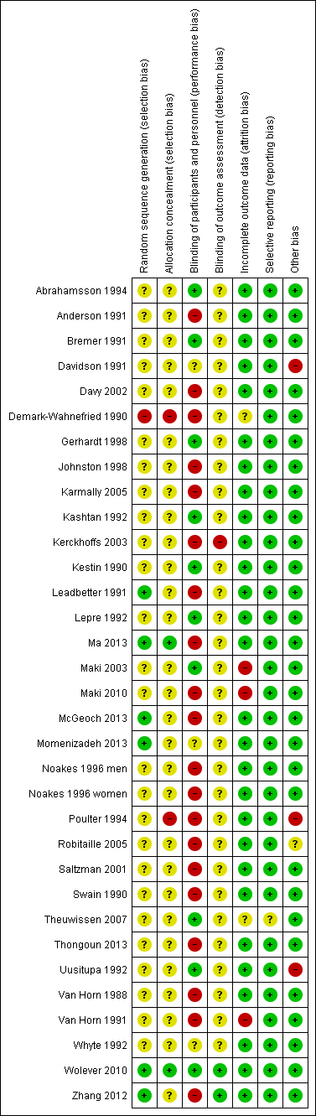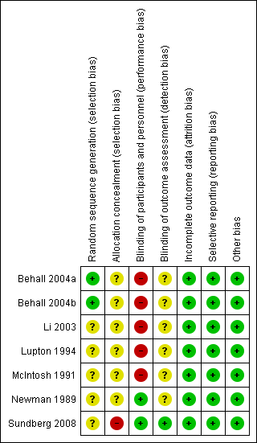
Barley
Oat

Appendix 5 – Risk of bias of studies included in the systematic review
Reference | Random sequence generation (selection bias) |  | Allocation concealment (selection bias) |  | Blinding of participants and personnel (performance bias) |  | Blinding of outcome assessors (detection bias) |  | Incomplete outcome data (attrition bias) |  | Selective reporting (reporting bias) |  | Other
Abrahamsson 1994 | ?¹ | Method not stated | ? | Not described | low | Double blind | ? | Not stated | low | 13% attrition | low | Expected outcomes reported | low
Amundsen 2003 | ? | Method not stated | ? | Not described | low | Participants blinded, not personnel | low | Blinded until study completion | high | 20% attrition | low | Expected outcomes reported | low
Anderson 1991 | ? | Method not stated | ? | Not described | high | Unclear, but obvious differences in foods | ? | Not stated | low | 5% attrition | low | Expected outcomes reported | low
Beck 2010 | low | Computer generated sequence | ? | Not described | low | Participants blinded, not personnel | ? | Not stated | high | 15% attrition, 30% in control group | low | Expected outcomes reported | low
Behall 1997 | high | Not described as randomised. However, gave the diets in different orders to different subjects | ? | Not described | ? | Not described | ? | Not stated | low | No attrition | Low | Expected outcomes reported | low | Cross-over design with meals provided
Behall 2004a | ? | Latin square | ? | Not described | high | Unclear, but obvious differences in foods | ? | Not stated | low | 7% attrition | low | Expected outcomes reported | low
Behall 2004b | ? | Latin square | ? | Not described | high | Unclear, but obvious differences in foods | ? | Not stated | low | 14% attrition | low | Expected outcomes reported | low
Biorklund 2005 (2 strata) | ? | Method not stated | ? | Not described | low | Participants blinded, not personnel | ? | Not stated | low | 11% attrition | low | Expected outcomes reported | low
Biorklund 2008 | ? | Method not stated | ? | Not described | low | Participants blinded, not personnel | ? | Not stated | low | no attrition | low | Expected outcomes reported | low
Braaten 1994 | ? | Method not stated | ? | Not described | high | Participants blinded, but correctly identified phase | ? | Not stated | low | 5% attrition | low | Expected outcomes reported | low
Bremer 1991 | ? | Method not stated | ? | Not described | low | Participants blinded, not personnel | ? | Not stated | low | no attrition | low | Expected outcomes reported | low
Chen 2006 | ? | Stratified by race and gender, method unclear | low | Opaque envelopes | low | Double blind | low | blinded | low | 7% attrition | low | Expected outcomes reported | low
Cugnet-Anceau 2010 | ? | Method not stated | ? | Not described | low | Double blind | ? | Not stated | high | 21% attrition | low | Expected outcomes reported | low
Davidson 1991 | ? | Stratified by LDL chol., method unclear | ? | Not described | ? | Personnel blinded, but groups received different number of packets | ? | Not stated | low | 5% attrition, intention-to-treat analysis performed | low | Expected outcomes reported | high | Pattern of baseline dietary fibre varies with intervention
Davy 2002 | ? | Method not stated | ? | Not described | high | Unclear, but obvious differences in foods | ? | Not stated | low | 11% attrition | low | Expected outcomes reported | low
Demark-Wahnefried 1990 | High | Sequential randomisation | high | Not detailed, unlikely with randomisation method | high | Not blinded | ? | Not stated | ? | 16% attrition, but unclear distribution | low | Expected outcomes reported | low
Gerhardt 1998 | ? | Method not stated | ? | Not described | low | Double blind | ? | Not stated | low | 10% attrition | low | Expected outcomes reported | low
Ibrugger 2013 (2 strata) | low | Computer generated sequence | ? | Not described | low | Double blind | Low | blinded | low | 19% attrition | low | Expected outcomes reported | low
Johnston 1998 | ? | Stratified by gender and LDL-C. Method not stated | ? | Not described | high | Unclear, but obvious differences in foods | ? | Not stated | low | 8% attrition | low | Expected outcomes reported | low
Karmally 2005 | ? | Block randomisation, method unclear | ? | Not described | high | Unclear, but obvious differences in foods | ? | Not stated | low | 4% attrition | low | Expected outcomes reported | low
Kashtan 1992 | ? | Method not stated | ? | Not described | low | Double blind | ? | Not stated | low | 11% attrition | low | Expected outcomes reported | low
Keogh 2003 | ? | Method not stated | ? | Not described | low | Participants blinded | ? | Not stated | low | no attrition | low | Expected outcomes reported | low
Kerckhoffs 2003 | ? | Stratified by gender and age, method unclear | ? | Not described | high | Not blinded | high | Not blinded | low | 6% attrition | low | Expected outcomes reported | low
Kestin 1990 | ? | Method not stated although design grid given | ? | Not described | low | Double blind | ? | Not stated | low | 14% attrition | low | Expected outcomes reported | low
Leadbetter 1991 | ? | Latin square | ? | Not described | high | Not blinded | ? | Not stated | low | 5% withdrew, but were replaced | low | Expected outcomes reported | low
Lepre 1992 | ? | Method not stated | ? | Not described | low | Double blind | ? | Not stated | low | 19% attrition | low | Expected outcomes reported | low
Li 2003 | ? | Method not stated | ? | Not described | high | Not blinded | ? | Not stated | low | No attrition | low | Expected outcomes reported | low
Lupton 1994 | ? | Method not stated | ? | Not described | high | Not stated, but one stratum involved capsule so unlikely | ? | Not stated | low | No attrition | low | Expected outcomes reported | low
Ma 2013 | low | Used a random number generator | low | Technicians and statisticians were blind | unclear | Not described but due to nature of intervention, unlikely | low | Technicians and statisticians were blind | low | Low attrition (5%) | low | Expected outcomes reported | low
Maki 2003 | ? | Method not stated | ? | Not described | low | Double blind | ? | Not stated | high | 38% attrition, per protocol analysis | low | Expected outcomes reported | low
Maki 2010 | ? | Method not stated | ? | Not described | high | Not blinded | ? | Not stated | high | 29% attrition per protocol analysis | low | Expected outcomes reported | low
McGeoch 2013 | low | Performed by independent statistician | ? | Not described | high | Not blinded | ? | Not stated | low | No attrition | low | Expected outcomes reported | low
McIntosh 1991 | ? | Method not stated | ? | Not described | high | Unclear, likely detectable differences in food | ? | Not described | low | No attrition | low | Expected outcomes reported | low
Momenizadeh 2014 | low | Used a random number generator | ? | Not described | ? | Not described | ? | Not described | low | Low attrition (6%) | low | Expected outcomes reported | low
Newman 1989 | ? | Method not stated | ? | Not described | low | Participants blinded | ? | Not stated | low | No attrition | low | Expected outcomes reported | low
Noakes 1996 (2 strata) | ? | Method not stated | ? | Not described | high | Unclear, but obvious differences in foods | ? | Not stated | low | No attrition | low | Expected outcomes reported | low
Onning 1999 | ? | Method not stated | ? | Not described | low | Participants blinded | ? | Not stated | high | 22% attrition | low | Expected outcomes reported | low
Pick 1996 | ? | Method not stated | ? | Not described | high | Not blinded | ? | Not stated | low | No attrition | low | Expected outcomes reported | low
Poulter 1994 | ? | Method not stated | high | Participants randomised to day of attendance | high | Not blinded | ? | Not stated | low | 8% attrition | low | Expected outcomes reported | high | Systematic differences between control and intervention periods
Robitaille 2005 | ? | Method not stated | ? | Not described | high | Not blinded | ? | Not stated | low | No attrition | low | Expected outcomes reported | ? | Intervention but not control group prepared muffins.
Rondanelli 2011 | low | Randomly permutated block randomisation list | low | Identical packaging | low | Double blind | ? | Not stated | low | No attrition | low | Expected outcomes reported | low
Saltzman 2001 | ? | Stratified by gender and age (and BMI in younger subjects), method unclear | ? | Not described | high | Unclear, but obvious differences in foods | ? | Not stated | low | No attrition | low | Expected outcomes reported, but not results of sub-group analysis | low
Swain 1990 | ? | Method not stated | ? | Not described | high | Participants blinded, but 90% correctly guessed intervention | ? | Not stated | low | 17% attrition | low | Expected outcomes reported | low
Sundberg 2008 | ? | Method not stated | low | Random allocation | low | Double blind | low | Blinded | low | 8% attrition | low | Expected outcomes reported | low
Theuwissen 2007 | ? | Method not stated | ? | Not described | low | Double blind | ? | Not stated | low | 2% attrition | low | Expected outcomes reported | low
Thongoun 2013 | ? | Method not stated | ? | Not described | ? | Not stated | ? | Not stated | low | 0% attrition | low | Expected outcomes reported | low
Torronen 1992 | ? | Method not stated | ? | Not described | low | Double blind | ? | Not stated | low | 7% attrition | low | Expected outcomes reported | low
Uusitupa 1992 | ? | Method not stated | ? | Not described | low | Double blind | ? | Not stated | low | 12% attrition | low | Expected outcomes reported | high | Uneven withdrawals created gender imbalance between groups
Van Horn 1988 | ? | Stratified by gender and total chol., method unclear | ? | Not described | high | Not blinded | ? | Not stated | low | 8% attrition | low | Expected outcomes reported | low
Van Horn 1991 | ? | Stratified by gender and total chol., method unclear | ? | Not described | high | Not blinded | ? | Not stated | high | 28% attrition | low | Expected outcomes reported | low
Vorster 1986 | ? | Method not stated | ? | Not described | low | Participants blinded | ? | Not stated | low | No attrition | low | Expected outcomes reported | low
Whyte 1992 | ? | Method not stated | ? | Not described | ? | Not stated | ? | Not stated | low | 4% attrition | low | Expected outcomes reported | low
Wolever 2010 | low | Computer generated | low | Sequentially numbered opaque envelopes | low | Double blind | low | Blinded | low | 6% attrition, intention-to-treat analysis performed | low | Expected outcomes reported | low
Zhang 2012 | ? | Method not stated | ? | Not described | high | Not blinded | low | Statistician blinded | low | 9% attrition | low | Expected outcomes reported | low
?, indicates unclear risk of bias

Appendix 6 – GRADE summary of findings table for β-glucan
Question: What is the food-health relationship between pure β-glucan and blood cholesterol concentration?

Quality assessment of body of evidence |  |  |  |  |  |  | Participants |  |  | Effect estimate | Quality  (degree of certainty in relationship)
Number of studies | Design | Risk of bias | Inconsistency | Indirectness | Imprecision | Considerations | Cross-over | P-INT. | P-CTL | Mean difference  (95% CI)
Change in total cholesterol
0 |  | Non-assessable | Not applicable | Not applicable | Not applicable | Not applicable | 0 | 0 | 0 | Non-assessable | Non-assessable
Change in LDL cholesterol
0 |  | Non-assessable | Not applicable | Not applicable | Not applicable | Not applicable | 0 | 0 | 0 | Non-assessable | Non-assessable
Change in HDL cholesterol
0 |  | Non-assessable | Not applicable | Not applicable | Not applicable | Not applicable | 0 | 0 | 0 | Non-assessable | Non-assessable

Appendix 7 – GRADE summary of findings table for oats*
Question: What is the food-health relationship between oats and blood cholesterol concentration?

Quality assessment of body of evidence |  |  |  |  |  |  | Participants |  |  | Effect estimate | Quality  (degree of certainty in relationship)
Number of studies | Design | Risk of bias | Inconsistency | Indirectness | Imprecision | Considerations | Cross-over | P-INT. | P-CTL | Mean difference  (95% CI)
Change in total cholesterol
33 | RCTs | Low¹ | None | None | None | None | 366 | 830 | 810 | -0.22  [-0.27, -0.17] | ⊕⊕⊕⊕  High
Change in total cholesterol – baseline total cholesterol <5.5 mmol/L
10 | RCTs | Low¹ | None | None | None | None | 92 | 302 | 311 | -0.21  [-0.31, -0.11] | ⊕⊕⊕⊕  High
Change in total cholesterol – baseline total cholesterol ≥5.5 mmol/L
23 | RCTs | Low¹ | None | None | None | None | 274 | 528 | 499 | -0.22  [-0.27, -0.17] | ⊕⊕⊕⊕  High
Change in LDL cholesterol
31 | RCTs | Low¹ | None | None | None | None | 366 | 699 | 672 | -0.21  [-0.24, -0.17] | ⊕⊕⊕⊕  High
Change in LDL cholesterol – baseline total cholesterol <5.5 mmol/L
9 | RCTs | Low¹ | None | None | None | None | 92 | 189 | 188 | -0.22  [-0.28, -0.15] | ⊕⊕⊕⊕  High
Change in LDL cholesterol – baseline total cholesterol ≥5.5 mmol/L
22 | RCTs | Low¹ | None | None | None | None | 274 | 510 | 484 | -0.20  [-0.25, -0.16] | ⊕⊕⊕⊕  High
No change in HDL cholesterol
30 | RCTs | Low¹ | None | None | None | None | 326 | 699 | 672 | 0.00  [-0.01, 0.00] | ⊕⊕⊕⊕  High

* Wholegrain oats and oat bran. P-INT: participants in intervention strata of parallel trials; P-CTL: participants in control stratum of parallel trials. ¹While less than half the studies were blinded, sensitivity analysis demonstrated similar effects between blinded and non-blinded trials.

Appendix 8 – GRADE summary of findings table for barley*
Question: What is the food-health relationship between barley and blood cholesterol concentration?

Quality assessment of body of evidence |  |  |  |  |  |  | Participants |  |  | Effect estimate | Quality  (degree of certainty in relationship)
Number of studies | Design | Risk of bias | Inconsistency | Indirectness | Imprecision | Considerations | Cross-over | P-INT. | P-CTL | Mean difference  (95% CI)
Change in total cholesterol
7 | RCTs | Low¹ | None | None | Serious# | None | 118 | 33 | 34 | -0.32  [-0.42, -0.21] | ⊕⊕⊕  Moderate
Change in total cholesterol – baseline total cholesterol <5.5 mmol/L
2 | RCTs | Low¹ | None | None | Serious# | None | 10 | 7 | 7 | -0.54  [-0.76, -0.33] | ⊕⊕⊕  Moderate
Change in total cholesterol – baseline total cholesterol ≥5.5 mmol/L
5 | RCTs | Low¹ | None | None | Serious# | None | 108 | 26 | 27 | -0.27  [-0.36, -0.18] | ⊕⊕⊕  Moderate
Change in LDL cholesterol
7 | RCTs | Low¹ | None | None | Serious# | None | 118 | 33 | 34 | -0.25  [-0.32, -0.18] | ⊕⊕⊕  Moderate
Change in LDL cholesterol – baseline total cholesterol <5.5 mmol/L
2 | RCTs | Low¹ | None | None | Serious# | None | 10 | 7 | 7 | -0.30  [-0.39, -0.20] | ⊕⊕⊕  Moderate
Change in LDL cholesterol – baseline total cholesterol ≥5.5 mmol/L
5 | RCTs | Low¹ | None | None | Serious# | None | 108 | 26 | 27 | -0.22  [-0.32, -0.13] | ⊕⊕⊕  Moderate
No change in HDL cholesterol
7 | RCTs | Low¹ | None | None | Serious | None | 118 | 33 | 34 | -0.03  [-0.06, 0.00] | ⊕⊕⊕  Moderate

* Wholegrain barley and non-concentrated barley products. P-INT: participants in intervention strata of parallel trials; P-CTL: participants in control stratum of parallel trials. ¹While only half the studies were blinded, sensitivity analysis demonstrated similar effects between blinded and non-blinded trials.
#Although the confidence intervals do not include the null value and exclude small effects, the number of participants was small and so the relationships were down-rated for serious imprecision.

Friedewald equation calculates LDL cholesterol using the following formula: LDL = total cholesterol – HDL cholesterol – (triglyceride / 2.2) where all concentrations are in mmol/L

